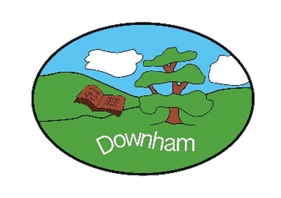
Downham C of E Primary School
Inspiring All to Soar to New Heights
“But those who hope in the Lord will renew their strength. They will soar on wings like eagles.” Isaiah 40:31



REPORTING YOUR CHILD’S ABSENCE USING STUDYBUGS

Downham C of E Primary School uses a new, more efficient and secure system for reporting your child’s absence called “Studybugs”.

If you haven’t already, please get the free Studybugs app, or register on the Studybugs website and use it to tell us whenever your child is ill or unable to attend school.

The tool helps us to know sooner if your child is unaccounted for. It is quick and easy to register and automatically reminds you to keep us posted.

Please use the following link to register: https://studybugs.com/about/parents

If you have any questions, please do not hesitate to contact the school office.

