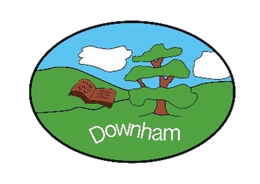
Downham C of E Primary School
Inspiring All to Soar to New Heights
“But those who hope in the Lord will renew their strength. They will soar on wings like eagles.” Isaiah 40:31
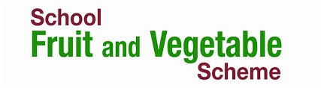

Dear Parent/Carer,
You may have heard about the Government’s School Fruit and Vegetable Scheme. Under the scheme, each child aged four to six in LEA-maintained schools is entitled to receive a free piece of fruit or vegetable each school day. The initiative behind the scheme is to encourage children to eat more fruit/vegetables and help towards their 5 a day, with the focus being on reducing obesity and reducing the risk of heart disease, stroke and some cancers. It is hoped that by educating the children of the benefits of healthy eating, they will continue to eat healthily in the future.
We are delighted that our school participates in this scheme, which reinforces our commitment to healthy eating. From September your child will be offered a free piece of fruit or vegetable each day.
The fruit and vegetables will be fresh and of good quality. The aim is for the children to have a positive and enjoyable experience of fruit and vegetables.
The scheme is voluntary, and although there is no obligation for your child to take part, we hope you will share our belief that it has many benefits. It is a great way to help us teach our children the benefits of healthy eating. If you do not wish your child to participate in the scheme, you must let us know before your child starts school. It is essential that you inform us of any allergies your child may have so that we can ensure they are not given anything that might harm them.
If you have any questions, please do not hesitate to contact us, or alternatively email the SFVS Team at sfvs@supplychain.nhs.uk.

