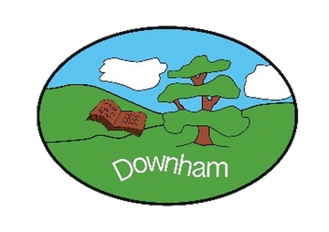
Downham C of E Primary School
Inspiring All to Soar to New Heights
“But those who hope in the Lord will renew their strength. They will soar on wings like eagles.” Isaiah 40:31

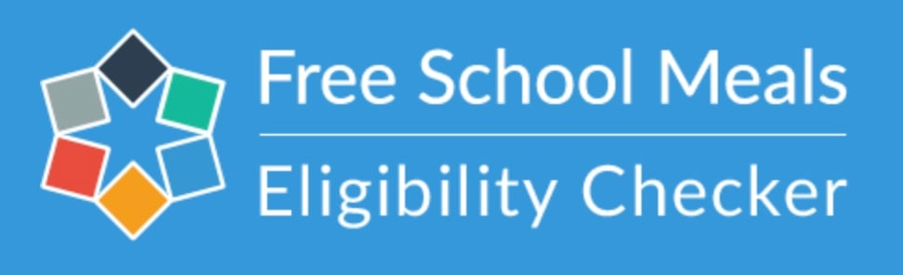

Dear Parents/Carers,

Currently, all children in EYFS and KS1 are entitled to receive school meals for free under the ‘Universal Free Infant School Meals’ initiative. Hot lunches are provided at Downham School and the menus change termly. Parents can order and pay for meals via ParentPay in advance for a current cost of £2.60 per daily. It is not possible to provide school lunches to those in arrears (in KS2) and a packed lunch will need to be brought in.

The school also receives additional funding – called Pupil Premium – for children of families that qualify for a free school meal not under the universal scheme. The Government uses the free school meals entitlement tests to assign any additional funding.

If Foundation Stage (Reception) parents do not apply, then additional funding is not awarded to the school.

The extra funding is used by the school to benefit and supplement the education of the children for whom are receiving this additional funding.

It is possible for the school to check which children are entitled to this funding, which will greatly benefit your child.

To complete the check, we require your National Insurance Number. We will inform parents/carers if additional funding has been secured for their child.

Due to new guidance from the Government, the eligibility check will need to be verified annually.

Please note that no-one will know that you have registered and it will not affect any other benefits that you are claiming. This is purely for additional school funding to support your child.

