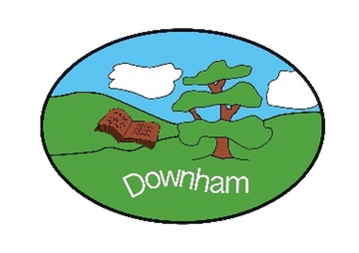
Downham C of E Primary School
Inspiring All To Soar To New Heights
“But those who hope in the Lord will renew their strength. They will soar on wings like eagles.” Isaiah 40:31
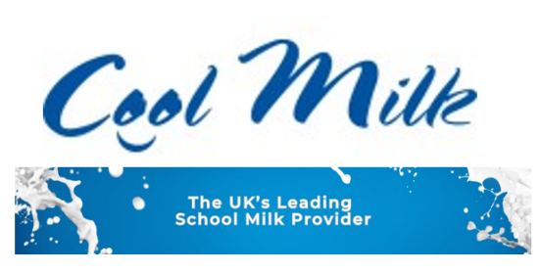

Dear Parent/Carer,

As you may be aware, we have a milk scheme, administered by Cool Milk. Mid-morning milk provides a much-needed nutritional boost and keeps children hydrated between breakfast and lunch. Children receive free milk until the age of 5. After that, they can continue to reap the benefits of fresh mid-morning milk at a subsidised cost.

If you’d like to opt in and have not already done so, simply register your child at
www.coolmilk.com/register. Your child(ren) will continue to receive free milk whilst under the age of 5 and Cool Milk will get in touch with further information by email shortly before their 5th birthday.

For children who are already over 5, it’s not too late – our scheme is flexible! As well as being able to register and make payment straight away, you can join and cancel the scheme at any time. We offer yearly, termly and half termly payment periods and a recurring payment option to give you one less thing to remember.

If you already have an online Cool Milk account for a sibling, you can manage your account, make payment and add extra children by logging in at www.coolmilk.com/parents.

Should you have any questions or need any help, send us a message at www.coolmilk.com/contact or give us a call on the number listed below – we’re here to help!

Kind regards,
Cool Milk
☎ 0800 321 3248
🌐 www.coolmilk.com

