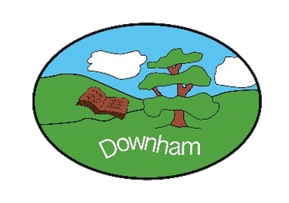
Downham C of E Primary School
Inspiring All to Soar to New Heights
“But those who hope in the Lord will renew their strength. They will soar on wings like eagles.” Isaiah 40:31
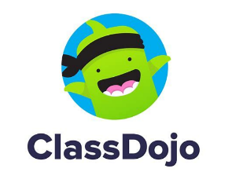

Dear Parents/Carers,

We use a free online communication platform (that works in a similar way to Facebook).

There are different elements to Class Dojo:

The School Story
By connecting your child, you will also see the ‘School Story’, which is a wall of announcements and photos for all parents across the school. This might be a reminder about a non-uniform day or a class assembly.

The Class Story
Once connected, your child’s teacher can broadcast information, photographs and videos using ‘Class Story’.

What do you need to do?
You will need to either download the Class Dojo app from your device’s app store or go to https://www.classdojo.com/ website. You will need to setup a parent account using your personal email address. We’ll send you a code so that you can connect your account to your child.

Is there a cost?
No, the part of Class Dojo that we are using are free for schools and parents. There is a section called ‘Class Dojo Beyond School’ which allows you to award Dojo points as a parent but this is a subscription service. Please be mindful of this and do not enter any payment details if you do not want to be charged.

Please note that Class Dojo is our main method for communication and therefore we strongly recommend that you download the app.

We will not be using the messaging function on Class Dojo. If you have a question for your child’s class teacher, please email them via the school office.

Please complete the attached parental permission form. Once this has been received we will send you an invite to use the platform via a secure QR code. Once you are connected, then you will be able to access the school and class story.

