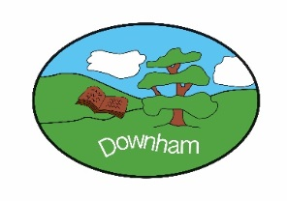
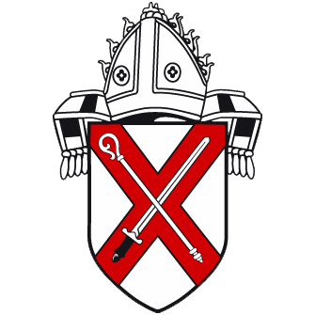


Curriculum Overview
Year 4
2026-2027
“Inspiring all to soar to new heights.”
Challenge Courage Collaboration Critical Thinking Creativity



Term | Autumn 1 | Autumn 2 | Spring 1 | Spring 2 | Summer 1 | Summer 2
Theme | Tomb Raiders | Sound of Music | Clans, Crowns and Kingdoms | Somewhere to Settle | Traders and Raiders | A Tale of Two Rivers
Curriculum Enrichment  (this list is not exhaustive) | Trip to British Museum  Baking hieroglyphic biscuits | Music videos  Performance to school | Runic alphabet and decoding messages  A Sutton-Hoo artefact hunt | Building online settlements. Local area geography walk | Making Viking bread  Class assembly to parents | Performance poetry  Art gallery to parents
Speaking & Listening | Targeted questioning / listening / referring back to the text | Targeted questioning / listening / referring back to the text | Targeted questioning / listening / referring back to the text | Targeted questioning / listening / referring back to the text | Targeted questioning / listening / referring back to the text | Targeted questioning / listening / referring back to the text
PE & Wellbeing  GET SET FOR PE | Yoga  Football | Hockey  Dance | Netball  Gymnastics | Tag Rugby  Fitness | Cricket  Athletics | Tennis  Rounders
PSHE | Families and friendships: Positive friendships, including online  Safe relationships: Responding to hurtful behaviour; managing confidentiality; recognising risks online  Respecting ourselves and others: Respecting differences and similarities; discussing difference sensitively |  | Belonging to a community: What makes a community; shared responsibilities  Media literacy and Digital resilience: How data is shared and used  Money and Work: Making decisions about money |  | Physical health and Mental wellbeing: Maintaining a balanced lifestyle; oral hygiene and dental care  Growing and changing: Physical and emotional changes in puberty; external genitalia; personal hygiene routines; support with puberty  Keeping safe: Medicines and household products; drugs common to everyday life
Phonics | RWI - Scheme of Learning and Progression
English
Driver Texts | Kensuke’s Kingdom | Beowulf | Matilda |  | The Borrowers | Macbeth
Poetry & Drama | How to build an image over a stanza | How to perform your own poem | How to write a cinquain | How to use metaphors | How to write a Tanka | How to communicate through poetry
Fiction | How to write a defeating the monster story | How to write a buddy story | How to balance telling description, dialogue and action | How to learn from an author | How to write a portal story | How to enjoy Shakespeare
Non-Fiction | How to write a recipe | How to write a newspaper report | How to write a guidebook | How to write a magazine article | How to write a letter | How to explain
Mathematics   | Place value  Addition and Subtraction | Area  Multiplication and Division A | Multiplication and Division B  Length and Perimeter | Fractions  Decimals A | Decimals B  Money  Time | Shape  Statistics  Position and Direction
 | Working scientifically: Pupils will experience different types of scientific enquiries, including practical activities, and begin to recognise ways in which they might answer scientific questions throughout each topic.
Science | Living things and their habitats and food chains | Sound | Electricity | Scientists & Inventors | Animals, including humans | States of matter, including the water cycle
Computing | Computing systems and networks – The Internet | Creating media - Audio production | Programming A – Repetition in shapes | Data and information – Data logging | Creating media – Photo editing | Programming B – Repetition in games
National Online Safety | SMART rules, logging on/off,  Online relationships  Online reputation  Online bullying |  | Self-image & identity  Health, wellbeing & lifestyle |  | Copyright & ownership  Privacy & security  Managing online information
Geography | Geographical skills and field work  Human Geography  Physical Geography |  | Geographical skills and field work  Human Geography |  | Locational Knowledge
History | Ancient Egypt |  | Anglo-Saxons vs Scots |  | Vikings
RE  Essex Agreed Syllabus | Theology: Asking questions theologians ask  Philosophy: Asking questions philosophers ask  Human/Social Sciences: Asking questions human and social scientists ask
RE  Essex Agreed Syllabus | Where do Christian religious beliefs come from? | What do we mean by truth? Is seeing believing? | How do/have religious groups contribute to society and culture? | Understanding Christianity – Salvation | Why is there so much diversity within Christianity? | What does sacrifice mean?
Charanga Music | Mamma Mia | Glockenspiel stage 2 | Stop! | Lean on me | Blackbird | Reflect, Rewind, Replay
French | Animals  Nouns  Numbers 0-12  Paris and London maps | Articles  Constructing simple sentences  Using adverbs and adjectives | Grammar: adverbs, nouns, conjunctions, adjectives, verbs, pronouns  Feminine words | Homophones  Agreement by gender  Questions | Definitive article  Likes and dislikes  Plurals  Use a numeral as a determiner | Write about myself  Comprehensions skills
DT | To master practical skills
DT | Textiles – Fastenings |  | Electrical systems - torches |  | Slingshot cars
Access Art Focus | Festival Feasts |  | Storytelling Through Drawing |  | Still Life

