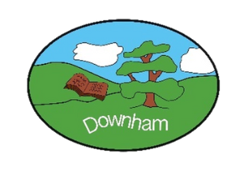
Home Learning Expectations 2026-2027

EYFS | Year 1 | Year 2 | Year 3 | Year 4 | Year 5 | Year 6*
Daily reading/  sharing of a book (10 mins) | Daily reading  (10 mins) | Daily reading  (10 mins) | Daily reading  (10 mins) | Daily reading  (15 mins) | Daily reading  (20 mins) | Daily reading  (20 mins)
 |  | CENTURY online home-learning (10 mins) | CENTURY online home-learning (15 mins) | CENTURY online home-learning (20 mins) | CENTURY online home-learning (20 mins) | CENTURY online home-learning (20 mins)
 | Phonics (5 mins) | Spelling Shed (5 mins) | Spelling Shed (5 mins) | Spelling Shed (10 mins) | Spelling Shed (10 mins) | Spelling Shed (10 mins)
 | Numbots (5 mins) | Numbots/TTRS (5 mins) | TTRS (5 mins) | TTRS (10 mins) | TTRS (10 mins) | TTRS (10mins)
 | Optional:  Weekly Topic Grid (see Dojo) | Optional:  Weekly Topic Grid (see Dojo) | Optional:  Weekly Topic Grid (see Dojo) | Optional:  Weekly Topic Grid (see Dojo) | Optional:  Weekly Topic Grid (see Dojo) | Optional:  Weekly Topic Grid (see Dojo)

*Note: homework may look different for Year 6 pupils, as they prepare for their SATs.

