Owls
Spring 2nd 2026


Dear Parents/Carers of Owls,

Thank you for your support and encouragement at the Parent / Teacher meetings; it is great to know that we are working together to help your child make progress in Year 5.

This Half-Term’s Learning
This half-term, Owls will be learning about the Colorado River. We will recapping on the water cycle and features of a river (from Year 4) and going on to study human geographical aspects of the river – types of settlement and land use, economic activity including trade links, and the distribution of natural resources. We are also looking forward to British Science Week.

Home Learning:
- Topic work may be presented during our Homework Celebration on Fridays. Feedback will be given verbally as each child presents his/her homework.
- Spelling will be taught daily. Children are expected to practise these spellings at home via the ‘Spelling Shed’ website. The children will also do ‘speedy spellings’ on a daily basis; this will be an opportunity to revise KS1 and Lower Key Stage 2 keywords.
- Children will be expected to practise their times tables regularly as well. Times Tables Rockstars is particularly useful for this and children should aim to complete 5 x 10 minute sessions each week.
- Please keep an eye on Class Dojo for information about Century Home Learning.

Reading:
- Reading diaries will be checked on Mondays.
- Please read with your child at home, ideally at least 4 times per week. This should be recorded in your child’s Reading diary.
- In class we will be continue our novel: Percy Jackson, the Lightning Thief.
- Children should have a ‘levelled’ reading book for when they are reading with an adult in school. Children will have access to other books in the classroom and library that they are welcome to take home to read.

General:
- Children may bring in stationery if they wish to do so. This may include glue sticks and whiteboard pens. Please ensure that these are labelled so the children know what belongs to them.
- Our PE days are Thursday (indoor) and Friday (outdoor) – please ensure children have the correct kit and footwear. (However, sometimes there are changes to the timetable so PE kits need to be in school all the time). PE kits can stay in school for the half-term.
- No jewellery is to be worn for PE lessons.
- Children may wear a watch and a pair of small silver/gold stud earrings for school – no bracelets.
- No makeup (including tinted lip balm and nail varnish) is to be worn.
- Hair is to be tied up at all times during the school day.
- Your child should bring in a snack, which they may eat at break time. This may include: a piece of fruit or vegetable, plain crackers, hummus, unprocessed cheese or plain rice cakes. A copy of the school snack policy can be found on the school website.
- Your child will also need a named bottle filled with water every day.
- Year 5 children will be dismissed from the back playground at the end of the school day. If you know that someone different will be collecting your child, please inform the school office who will get the message to us.

Should you have any questions, please feel free to write a note in your child’s reading diary, send an email via the school office (office@downham-ceap.essex.sch.uk) or catch me at the end of the day once all the children have been collected.

Kind regards,

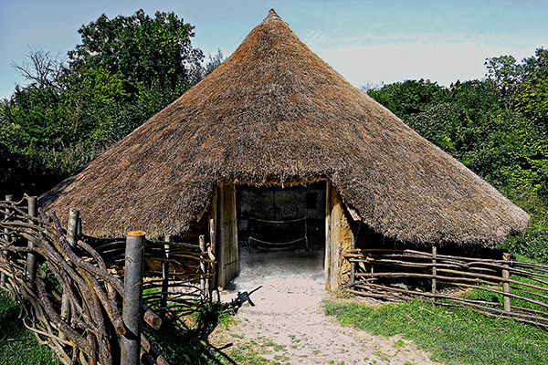
Miss Boyd




