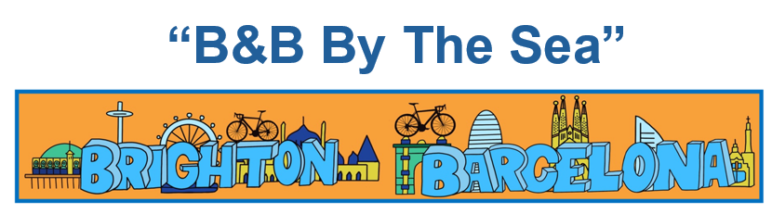

Y3 - Woodpeckers
Spring 2nd 2026


Dear Parents/Carers of WOODPECKERS,

We hope that you had a restful half-term break with your family. Can you believe that we are now half-way through year 3?!

This Half-Term’s Learning
Our topic this half-term is called, “B&B By The Sea”. We will travel from Brighton; a vibrant seaside city known for its lively atmosphere and creative culture to beautiful Barcelona; a city of contrasts, situated on the northeastern coast of Spain along the Mediterranean Sea. We will explore the similarities and differences between these two coastal cities, learn about their history and the impact of tourism and further develop our mapwork skills. Please see the ‘Topic Overview’ for more information about what else we are learning this half term.

To ‘hook’ the children into the topic we compared the Brighton and Barcelona football badge and designed a new one. For the topic ‘outcome’ we will be having a Spanish-themed day in school where the children will get to take part in a range of activities including food tasting, arts and crafts, music and dance. Children are also invited to dress up – in traditional Spanish outfits, red and/or yellow or a famous Spanish person. This will be during the last week of the half-term. Date TBC.

We will be sewing as part of our DT this half-term and I will be looking for some of our DBS Woodpecker parents to come in and help. You don’t have to be an expert but you will need patience for threading lots of needles!

Home Learning:

- We are excited to announce that the Trust have bought into ‘Century’ for the children to enhance their English and maths skills as part of their home learning. The children will be set a couple of ‘nuggets’ (videos/questions) per week. I know it is tempting to ‘help’ the children with their home learning, however, it does need to be their work! Century is intuitive - if children are struggling with a ‘nugget’ (concept) then it will adapt the questions accordingly and address any misconceptions. We hope that you and the children find this new learning platform beneficial.
- Children will come home with their log in details this week.
- Many of the children (and parents) love the topic home learning activities – these will be posted on Dojo the beginning of a half-term and will be optional. We will continue to celebrate/display any work sent in.

- Spelling will be taught twice a week. Children are expected to practise these spellings at home via the ‘Spelling Shed’ website.


- Continue to play Times Tables Rockstars, ideally on a daily basis for 3-5 minutes. For your information, by the end of year 3, children will be expected to know: x2, x5, x10, x3, x4 and x8 times tables.

Reading:
- Reading diaries are to be brought into school every day.
- Children will be expected to read at home at least 5 times a week. Ideally, this will be with/to an adult. Reading is to be recorded in your diary which will be checked and signed on a Monday. Please ensure that diaries are completed, signed and ready to be checked on a Monday.
- The aim is to read at least 50 times in a term. Any children who read 50 times or more will be presented with a special certificate at the end of the term.
- Please note that it is absolutely fine for your child to record their reading, however we ask that you then sign their diary over the weekend ready to be handed in on a Monday.
- Children will participate in daily reading sessions, where they will have the opportunity to discuss a book as a whole class. Our class book this half-term is ‘The Iron Man’. In addition to this, there will be opportunities for the children to read to themselves and 1:1 to an adult with a levelled book. We encourage the children to keep this book in their school bag so that it is always available. Children will have access to other books in the classroom and library that they are welcome to take home to read. Please ensure that books are returned so that others may enjoy them too.

General:
- Children will come in and out of school via the old library door. In the morning, please say goodbye at the brown gate and let your child walk independently down to the door which opens at 8.40am. Registration is at 8.50am.
- If you have a message for us, please inform the member of staff on the gate who will pass it on. At the end of the day (3.15pm) please come and wait by the blue gate opposite the classroom door where we will dismiss the children 1 by 1. It would be helpful if you give us a wave! If you know that someone different will be collecting your child, please inform the school office who will get the message to us.
- Children do not need to bring in stationery, however, they may like to bring in a small pencil case of colouring pencils to keep in their tray.
- Our PE days are Monday and Wednesday – please ensure children have the correct kit and footwear. (However, sometimes there are changes to the timetable so PE kits need to be in school all the time).
- No jewellery is to be worn for PE lessons
- Children may wear a watch and a pair of small silver/gold stud earrings for school – no bracelets
- No makeup (including tinted lip balm and nail varnish) is to be worn
- Hair is to be tied up (with an appropriate school-coloured and sized hairband) at all times during the school day.
- Children should wear black school shoes or plain black trainers to school every day
- Your child should bring in a snack to enjoy during breaktime. This may include: a piece of fruit or vegetable, plain crackers, hummus, unprocessed cheese or plain rice cakes. A copy of the school snack policy can be found on the school website. Please label snack pots with your child’s name.
- Your child will also need a named bottle filled with water every day. This will be kept in a tray at the back of the classroom. They will be able to access and refill their water bottle throughout the day. Space is limited therefore please ensure that bottles are appropriately sized e.g. 500ml.

Other information:
- Easter Service at Chelmsford Cathedral – Wednesday 25th March (pm)
- Woodpeckers are off to Colchester Castle on Wednesday 6th May as part of their learning about the Romans in Britain. A letter with more details will be emailed later this half-term.

Should you have any questions, please feel free to write a note in your child’s reading diary, send an email via the school office (office@downham-ceap.essex.sch.uk) or catch us at the end of the day once all the children have been collected.

Kind regards,
Miss Proctor & Mrs Chapple

