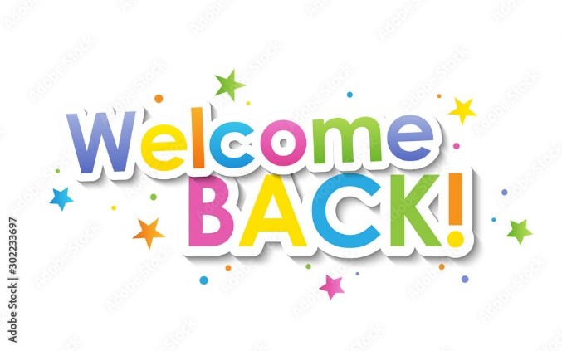
Ducklings
Spring 2nd 2026

Dear Parents/Carers of Ducklings,

Welcome back to the second half of the Spring Term. We hope you had a relaxing half term break and cannot wait to hear what the children have been up to! We are hoping for some warm, sunny days so we can get outside with our learning much more.

This Half-Term’s Learning

Our topic this half term is called “Animals and Aliens”
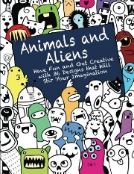
RWI phonics | Recap on set 1 and 2 sounds. Secure blending on words containing all set 1 sounds. Children are taught to blend words containing 4/5 sounds and consonant blends. Read some common exception words: put, the, I, no, of, my, for, he and begin to blend “alien” words confidently and securely.
Maths | Bonds to 10  Including doubles | Exploring odd and even | 2D and 3D shapes | Complex patterns | Copy and continue patterns

In this topic we will read stories such as “Giraffes Can’t Dance” and “Elmer” and discuss how we are all different and not everyone is good at the same thing. We will talk about and create different environments related to different parts of the world, jungle, desert, ocean, space. We will construct homes using different construction materials and paint pictures using different materials, such as bubble wrap to create different textures. We will sort animals using different criteria and use technology to do some research.

Adults in Class
I will be in class each day supported by our wonderful Teaching Assistants. Mrs Flood will be in class on a Monday, Tuesday and Wednesday morning.
Mrs Rivett will be with us every day.
Mrs Dearman will cover my PPA and leadership time.
Miss Wison and Mrs Valentine are our Forest School Leads.

Reading and Home Learning:

- The children are doing so well learning their sounds with Fred the Frog, using Fred Talk, to help them read new words and using their Fred Fingers to help them spell words. Please use the QR codes at home to help learn our Set 2 “special friends”

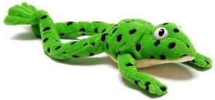
- Your child will continue to bring home Ditty sheets and/or a coloured RWI book bag book to read at home. This book has been rehearsed in school and the children should be able to read it confidently.

- The children will also bring home a “Have A Go” book (not linked to RWI) to share at home. Please use the week to re-read the book, asking questions about what happens in the story, favourite pictures and why etc. This all helps with comprehension skills.

- The children are also free to choose a book form the class library and reading area to read at home. These books can be changed whenever your child is ready.

School Dinners

Please remember: All meals must be pre-ordered (and paid) on the ParentPay website. Class teachers will no longer be taking a lunch register. Any children without a prebooked lunch must have a packed lunch. The children can get very upset if a lunch has not been ordered or they do not know what they are having.

General:

- Our PE days remains as a Monday – please ensure children have the correct kit and footwear. Please make sure that the girls have socks in their PE bags if they are wearing tights during the colder months.

- No jewellery is to be worn for PE lessons. If your child has earrings please make sure these are removed for PE. We are not allowed to remove or cover earrings.

- Please do name all PE kit and all items of uniform, including shoes. We cannot return missing items if they are not named.

- Long hair is to be tied up (with an appropriate coloured and sized hairband) at all times during the school day.

- Your child will need a named bottle filled with water every day. This will be kept in a tray in the classroom. They will be able to access and refill their waterbottle throughout the day.

- A plea – we have no spare socks (grey or white) or tights left at school in our “spare clothes” drawer. These are often sent home after an accident but we very rarely get them back. Could you please check at home and see if you have any that could possibly belong to school. Many thanks.

- A reminder, if you know that someone different will be collecting your child, please inform the school office who will get the message to us.

Should you have any questions, please feel free to send an email via the school office
(office@downham-ceap.essex.sch.uk) or catch us at the end of the day once all the children have been collected.

Here is to a happy and exciting half term!

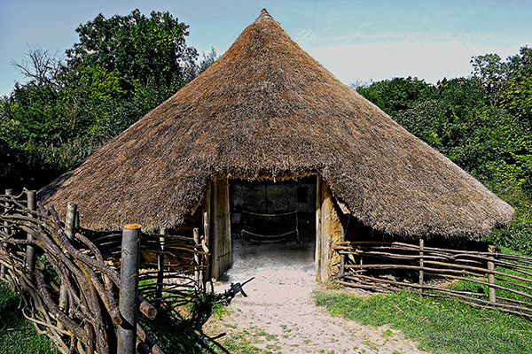
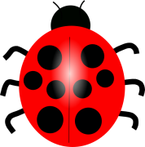
Mrs Applewhite and the EYFS Team

