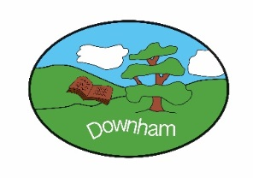
Year 5 – Owls


Spring 2nd 2026
Topic Overview:
This half-term, Owls will be learning about the Colorado River. We will recapping on the water cycle and features of a river (from Year 4) and going on to study human geographical aspects of the river – types of settlement and land use, economic activity including trade links, and the distribution of natural resources. We are also looking forward to British Science Week.

Outcome:
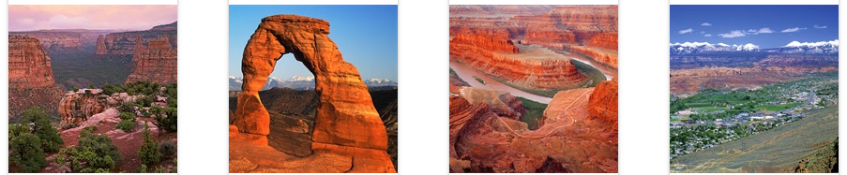

We will be scripting and filming a travel documentary about the Colorado River. Highlights will include both natural and man-made locations, such as Grand Canyon and the Davis Dam.
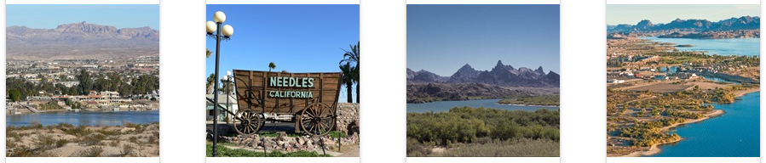
Hook:
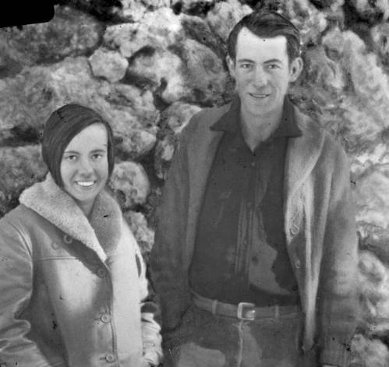
We will begin our topic with a mystery – what happened to Bessie and Glen Hyde, honeymooners on a Colorado River adventure in 1928? They vanished without a trace; can Owls solve the mystery?
What’s being covered?
Maths | Decimals and percentages, perimeter and area, statistics
English | Defeating a Monster story, Blogs, Portal Stories
 | Topic | Skills
Geography | A Force of Nature | Locational knowledge  - locate the world’s countries, using maps to focus on Europe (including the location of Russia) and North and South America, concentrating on their environmental regions, key physical and human characteristics, countries, and major cities  - identify the position and significance of latitude, longitude, Equator, Northern Hemisphere, Southern Hemisphere, the Tropics of Cancer and Capricorn, Arctic and Antarctic Circle, the Prime/Greenwich Meridian and time zones (including day and night)  Human and physical geography  Describe and understand key aspects of:  - physical geography, including: climate zones, biomes and vegetation belts, rivers, mountains, volcanoes and earthquakes, and the water cycle  - human geography, including: types of settlement and land use, economic activity including trade links, and the distribution of natural resources including energy, food, minerals and water  Geographical skills and fieldwork  - use maps, atlases, globes and digital/computer mapping to locate countries and describe features studied  - use the eight points of a compass, four and six-figure grid references, symbols and key (including the use of Ordnance Survey maps) to build their knowledge of the United Kingdom and the wider world
Art | Mixed Media – Land and City Scapes | - understand that artists often work outside, finding inspiration from the land and city scapes  - extend a sketchbook by adding pages of different sizes and ratios to make drawings more interesting  - create lots of mixed media drawings/paintings in a sketchbook that capture the spirit and energy of the environment  - display work and reflect on the outcomes
Music | Fresh Prince of Bel Air | - play and perform in solo and ensemble contexts, using their voices and playing musical instruments with increasing accuracy, fluency, control and expression  - improvise and compose music for a range of purposes using the inter-related dimensions of music  - listen with attention to detail and recall sounds with increasing aural memory  - use and understand staff and other musical notations  - appreciate and understand a wide range of high-quality live and recorded music drawn from different traditions and from great composers and musicians▪ develop an understanding of the history of music
Science | Scientists and Inventors | - identify scientific evidence that has been used to support or refute ideas or arguments  - describe how scientific ideas have changed over time  - describe the movement of the Earth, and other planets, relative to the Sun in the solar system  - describe the life process of reproduction in some plants and animals  - compare and group together everyday materials on the basis of their properties, including their hardness, solubility, transparency, conductivity (electrical and thermal), and response to magnets  - plan different types of scientific enquiries to answer questions  - use test results to make predictions  - use knowledge of solids, liquids and gases to decide how mixtures might be separated
Computing | Data & Information | Flat-file databases  - Use search technologies effectively, appreciate how results are selected and ranked, and be discerning in evaluating digital content  - Select, use, and combine a variety of software (including internet services) on a range of digital devices to design and create a range of programs, systems, and content that accomplish given goals, including collecting, analysing, evaluating, and presenting data and information
PSHE | Citizenship | - Understand what happens when someone breaks the law.  - Understand what rights are and that freedom of expression is one of these rights.  - Understand how reducing the use of materials and energy helps the environment, and what individuals can do to support this.  - Understand how people contribute to society and how this is recognised.  - Understand the role of pressure groups.  - Understand the basics of how parliament works including the parts of parliament.
French | Town and Time | - More Places around Town  - Telling the Time  - Paris and Tokyo
RE | What difference does the resurrection make to Christians? | - explore what makes an event worth celebrating  - compare different Gospel accounts of the death of Jesus  - compare different Gospel accounts of the resurrection of Jesus  - find evidence of the resurrection within a Biblical text (Luke 24)  - make connections between sacrifice in the Old and New Testaments (with Jesus being the ultimate sacrifice)  - describe the significance of resurrection and how it shapes how Christians see the world and others
Indoor PE | Fitness | - physical – agility, balance, co-ordination, speed, stamina, strength  - social – collaboration, support, communication  - emotional – perseverance, determination  - thinking – feedback, comprehension, observation, evaluation
Outdoor PE | Football | - Control the ball using either foot when moving  - Pass the ball with inside, front or laces on the foot  - Dribble the ball using inside, outside hook and drag back beginning to accelerate  - Show good body position to defend and press in a 2v2 game  - Scoring using top of foot (laces)- aiming for corners of the goal  - Begin to use attacking and defending, techniques learned in a game situation  - In teams, begin to discuss tactics and how to work as a team (communicate and collaborate)

