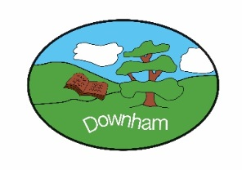
Year 1 - Robins

“Our School”

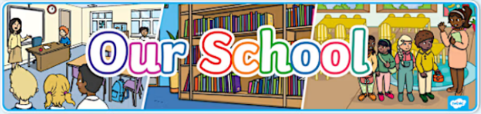
Spring 2nd - 2026
Our topic for this half term will be Our School. Throughout the topic, Robins will be identifying key features of their environment and understanding their roles within the school community. The curriculum also features hands-on activities such as creating simple printmaking in art and celebrating Easter by making chocolate nests and greeting cards.
Hook:  Celebrating Easter and making chocolate Easter nests. |  |  | Outcome:  To identify key features of their school environment, explain its history within living memory, and demonstrate an understanding of their role within the school community.
What’s being covered?
English | This half term, our young authors are transitioning from short sentences to crafting longer story narratives, focusing on building engaging characters and exciting plot sequences. We will also explore the world of non-fiction through report writing, teaching the children how to organise facts using headings and technical vocabulary. By practicing both imaginative and informative styles, students will develop the stamina and versatility needed for more complex writing.
Maths | This half term, we will be expanding our number sense by exploring Place Value within 50, focusing on partitioning tens and ones to build a strong numerical foundation. We will also dive into practical measurement, gaining hands-on experience with Length and Height using both non-standard and standard units. To end the term, we will develop our "estimation powers" by comparing and measuring Mass and Volume with various classroom objects.
Subject | Topic | Skills
Science | Scientist & Inventors | - To understand how David Attenborough teaches us about animals and the natural world  - To find out how Jane Goodall studied chimpanzees and cared for animals  - To learn how Stephanie Kwolek invented a strong material that helps keep people safe  - To discover how Ole Kirk Christiansen invented LEGO to help people build and create
Geography  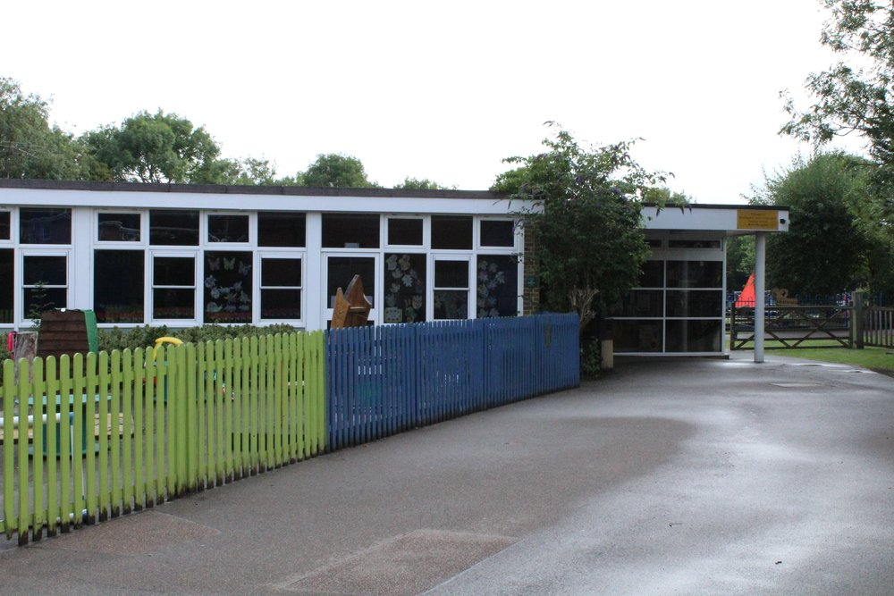 | Geographical skills and fieldwork | - To look at simple maps  - To use positional and directional language  - To observe the local environment  - To record data  - To design a new playground
Art  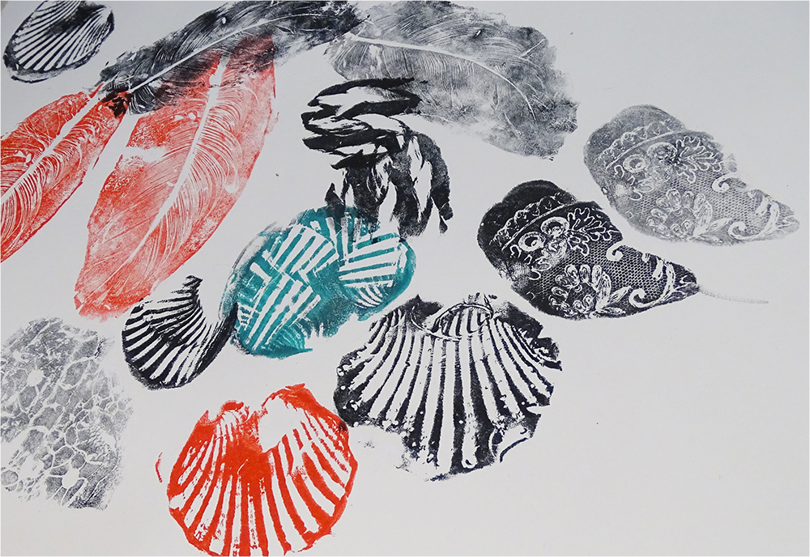 | Simple Printmaking | - To print with our bodies  - To make rubbings  - To use plasticine printing  - To use foam printing  - To reflect and discuss
Music  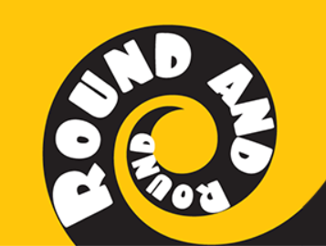 | Pop music – using your imagination | - Round And Round (Bossa Nova) by Joanna Mangona  - Livin’ La Vida Loca (Latin/Pop) by Ricky Martin  - The Imperial March, Darth Vader’s Theme (March Of The Empire) (Film) by John Williams  - It Had Better Be Tonight (Latin/Big Band) by Michael Bublé  - Play and perform Round and Round
Computing   | Data & information – Grouping data | - To label objects  - To identify that objects can be counted  - To describe objects in different ways  - To count objects with the same properties  - To compare groups of objects
PHSE   | Economic Wellbeing | - To discover what money is and how it helps us  - To consider ways to keep coins safe  - To recognise the purpose of banks and building societies  - To begin to understand the differences between spending and saving money  - To identify the different job roles in and out of school
RE  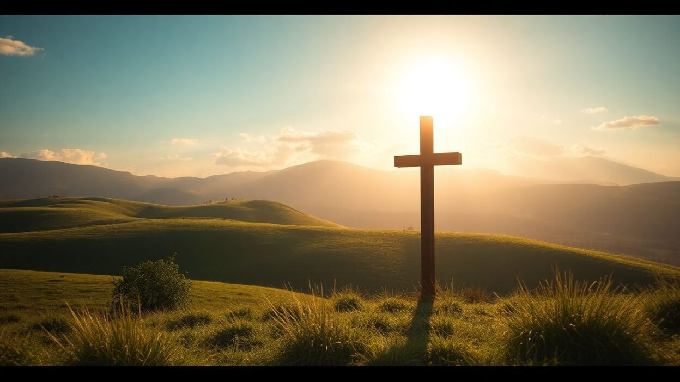 | Understanding Christianity: Salvation | - To explore the Easter story  - To explore different crosses and crucifixes  - To design and create Easter greeting cards  - To create an Easter garden  - To discuss why hope is important
PE (indoor)   | Team Building | - To co-operate with a partner to complete challenges  - To explore and develop working as a team  - To develop talking, listening and sharing skills  - To use speaking and listening skills to lead a partner  - To use talking, listening and sharing skills to complete challenges

