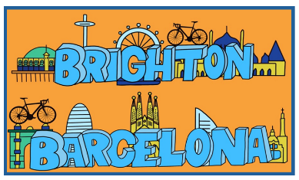
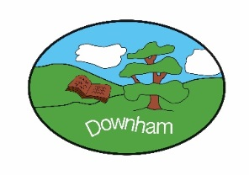
Year 3 – Woodpeckers
Class Novel
The Iron Man
“B&B By The Sea”
Spring 2nd 2026

Topic Overview:
Join us as we travel to the south coast city of Brighton; a vibrant seaside city known for its lively atmosphere and creative culture, to beautiful Barcelona; a city of contrasts, situated on the northeastern coast of Spain along the Mediterranean Sea. We will explore the similarities and differences between these two coastal cities, learn about their history and the impact of tourism and further develop our mapwork skills.

Outcome:
A Spanish-themed day including food tasting, arts and crafts, music and dance
Hook:
Redesigning the Brighton and Barcelona Football Badge

What’s being covered?
 | Topic | Skills
Geography  & History | Human and physical geography – comparing Brighton and Barcelona | - Locational knowledge: Similarities and differences through the study of human and physical geography of a region of the UK and Europe (Brighton and Barcelona)  - Human Geography: Explain how humans use physical geographical features for a variety of purposes.
DT | Textiles – cross stitch and applique | - Select and cut fabrics with ease using fabric scissors.  - Thread needles and tie knots with greater independence.  - Sew cross-stitch to join fabric.  - Decorate fabric using appliqué.  - Evaluate end product
Science | Scientists and Inventors | - “British Science Week”
Music | The Dragon Song | - Listen and Appraise – Chinese Folk Music; Hindu Song, Traditional Turkish Tune, Polynesia Drum Dance, Zebaidir Song from Sudan  - Sing and play instrumental parts  - Improvise using voices and/or instruments  - Perform composition within the song
Computing | Branching Databases | - Understand what data is and how it can be organised  - Use yes/no questions to sort data.  - Sort objects into groups  - Use a branching database.
PSHE | Citizenship | - Explain that children have rights and how these benefit them.  - Explain the responsibilities adults have for supporting children’s rights.  - Discuss the benefits of recycling.  - Recognise some of the different groups within the local community and how they use local buildings.  - Explain how charities support the local community.  - Describe how democracy works locally and how this affects us.  - Recognise the need for rules and the consequences of breaking rules.
French | Introduction to French | - Learn how to greet and say goodbye  - To learn how to ask and say your name  - To learn how to say and respond to classroom instructions  - To identify France and Paris on a map and learn about the culture  - To learn the numbers 1-10  - UK countries and capitals
RE | Understanding Christianity: Salvation | - Offer suggestions for what the texts about the entry into Jerusalem and the death and resurrection of Jesus might mean  - Give examples of what the texts studied mean to some Christians  - Make simple links between the Gospel texts and how Christians mark the Easter events in church communities  - Describe how Christians show their beliefs about Palm Sunday, Good Friday and Easter Sunday in Worship  - Make some links between some of the stories and teachings in the Bible and life in the world today expressing some ideas of their own clearly.
PE | Fitness  Football | - Agility: show balance when changing direction.  - Balance: explore more complex activities which challenge balance.  - Co-ordination: co-ordinate my body with increased consistency in a variety of activities.  - Speed: explore sprinting technique.  - Strength: explore building strength in different muscle groups.  - Stamina: explore using my breath to increase my ability to work for longer periods of time.  - Dribbling: dribble a ball with hands and feet with control.  - Sending & receiving: explore s&r abiding by the rules of the game.  - Dribbling: explore dribbling the ball abiding by the rules of the game under some pressure.  - Space: develop using space as a team.  - Attacking: develop movement skills to lose a defender. Explore shooting actions in a range of invasion games.  - Defending: develop tracking opponents to limit their scoring opportunities.

