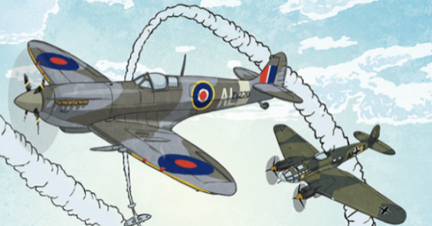
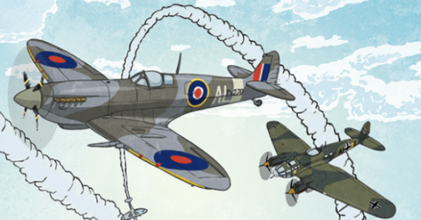
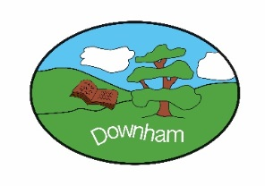
Year 6 – Eagles
Blitzed
Spring 2nd 2026
Topic Overview:
In our new topic, ‘Blitzed’, we will be learning about World War II, with a focus on the Battle of Britain. Through this engaging topic, the children will explore the challenges faced by people during the Blitz and how Britain responded. In English, we will be linking this topic to create a consequence narrative, where students will write their own stories inspired by the war. Additionally, they will craft a 'How to Survive an Air Raid' guide, and engage in letter writing, imagining what life was like during this turbulent time. Our music topic ‘You’ve Got a Friend’, fits perfectly with the camaraderie shown by the soldiers in World War II. Alongside this, we will also be revising key concepts for SATs. We look forward to a term full of learning and creativity!

Outcome:
Evacuation to the ‘countryside’ afternoon
Hook:
Creating Propaganda posters
What’s being covered?
Maths | Fractions, decimals and percentages, area, perimeter and volume, statistics, SATS Revision
English | Classical Poetry, Narrative, letter writing,
 | Topic | Skills
History | WW2  ‘The Blitz/Battle of Britain ‘ | - Pupils should continue to develop a chronologically secure knowledge and understanding of British, local and world history, establishing clear narratives within and across the historical periods.  - They should note connections, contrasts and trends over time and develop the appropriate use of historical terms.  - They should regularly address and sometimes devise historically valid questions about change, cause, similarity and difference, and significance.  - They should construct informed responses that involve thoughtful selection and organisation of relevant historical information.  - They should understand how our knowledge of the past is constructed from various sources.
Art | Activism | - Pupils should be taught to develop their techniques, including their control and their use of materials, with creativity, experimentation and an increasing awareness of different kinds of art, craft and design.  - to create sketch books to record their observations and use them to review and revisit ideas  - to improve their mastery of art and design techniques, including drawing, painting and sculpture with a range of materials [for example, pencil, charcoal, paint, clay]  - to know about great artists, architects and designers in history.
Music | You’ve Got a Friend | - Describe the style indicators of the song/music.  - Describe the structure of the song.  - Identify the instruments/voices they can hear.  - Talk about the musical dimensions used in the song.  - Find the pulse  - Copy back rhythms based on the words of the main song, that include syncopation/off beat  - Copy back one-note riffs using simple and syncopated rhythm patterns
Science | Scientists and Inventors | - To report and present findings from enquiries, including causal relationships, in oral and written forms such as displays and other presentations in context of Stephen Hawking.  - To give reasons for classifying plants and animals based on specific characteristics in context of Libbie Hyman.  - To recognise the impact of diet, exercise, drugs and lifestyle on the way their bodies function in context of Marie Maynard Daly.  - To record data using scatter graphs in the context of Fleming’s discovery of penicillin.  - To recognise that living things have changed over time and that fossils provide information about living things that inhabited the Earth millions of years ago in the context of Mary Leakey’s fossil findings in the Olduvai Gorge  - To identify and name the main parts of the human circulatory system, and describe the functions of the heart, blood vessels and blood in the context of finding out about Dr Daniel Hale Williams.
Computing | Introduction to spreadsheets | - To create a data set in a spreadsheet.  - To build a data set in a spreadsheet  - To explain that formulas can be used to produce calculated data  - To apply formulas to data  - To create a spreadsheet to plan an event  - To choose suitable ways to present data
PSHE | Media literacy and Digital Resilience | - about the benefits of safe internet use e.g. learning, connecting and communicating  - how and why images online might be manipulated, altered, or faked  - how to recognise when images might have been altered  - why people choose to communicate through social media and some of the risks and  - challenges of doing so  - that social media sites have age restrictions and regulations for use  - the reasons why some media and online content is not appropriate for children  - how online content can be designed to manipulate people’s emotions and encourage them to read or share things  - about sharing things online, including rules and laws relating to this  - how to recognise what is appropriate to share online  - how to report inappropriate online content or contact
French | In town | - Listen attentively to spoken language and show understanding by joining in and responding  - Explore the patterns and sounds of language through songs and rhymes and link the spelling, sound and meaning of words  - Engage in conversations; ask and answer questions; express opinions and respond to those of others; seek clarification and help  - Speak in sentences, using familiar vocabulary, phrases and basic language structures  - Develop accurate pronunciation and intonation so that others understand when they are reading aloud or using familiar words and phrases
RE | Big Question:  What difference does the resurrection have for Christians? | Philosophy  - The Nature of knowledge, meaning and existence Begin to analyse and evaluate a range of philosophical answers to questions about the world around them, including questions relating to meaning and existence. Begin to analyse and evaluate different ways in which philosophers understand abstract concepts.  - How and whether things make sense Begin to analyse and evaluate whether a position or argument is coherent and logical and show increasing awareness of divergence of opinion. Use well-chosen pieces of evidence to support and counter a particular argument  - Issues of right and wrong, good and bad Begin to analyse and evaluate a range of different answers to ethical and moral questions/issues, showing an understanding of the connections between beliefs, practices and behaviour.
PE  (Indoor) | Fitness | - To develop an awareness of what your body is able to do.  - To develop speed and stamina.  - To develop strength using my own body weight.  - To develop co-ordination.  - To develop agility.  - To develop balancing with control.
PE  (Outdoor) | Tag Rugby | - Create and use space to help my team.  - Pass, receive and shoot the ball with increasing control under pressure.  - Select the appropriate action for the situation and make this decision quickly.  - Use marking, and/or interception to improve my defence.  - Use the rules of the game consistently to play honestly and fairly.  - Work collaboratively to create tactics with my team and evaluate the effectiveness of these.  - Work in collaboration with others so that games run smoothly.  - Recognise my own and others strengths and areas for development and can suggest ways to improve.

