
Ducklings
Spring 1st 2026

Dear Parents/Carers of Ducklings,

Welcome back and a very Happy New Year!
We hope you had a wonderful Christmas and are looking forward to the coming half term.
This Half-Term’s Learning

Our topic this half term is called “Once Upon a Story”
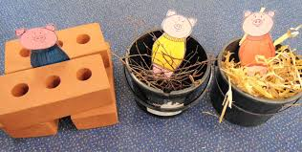
Our new topic is based around Traditional Tales. The stories we will focus on include Goldilocks and the Three Bears, Hansel and Gretel, Jack and the Beanstalk, Little Red Riding Hood, The Gingerbread Man and the Three Little Pigs, however we will also cover a selection of other stories. If you have a favourite Traditional Tale from your own family or culture please share this with us as we want the traditional tales to reflect the children in our class. You can help at home in a number of ways including reading a variety of Traditional Tales to support your child to be as familiar with these stories as possible. Discuss the beginning, middle and end of stories and how the writer keeps the reader interested.

RWI phonics | A focus on consolidating Set 1 sounds, introducing Set 2 sounds, and developing the ability to blend sounds to read and write simple words and sentences.
Maths | Alive in 5! | Mass and Capacity | Growing 6,7,8 | Deepening  Understanding | Consolidation

Adults in Class
I will be in class each day supported by our wonderful Teaching Assistants. Mrs Flood will be in class on a Monday, Tuesday and Wednesday morning, Mrs Rivett will be with us every day. Mrs Gristwood volunteers each Wednesday.
Mrs Dearman will be with us on a Fridy and will also cover my PPA and any leadership time. Forest School ladies, Miss Wilson and Mrs Valentine, will be with us each Thursday morning.

Class Dojo
Have you signed up to use Class Dojo yet? We still have not got 100% of families signed up.
What do you need to do?
1. You will need to either download the Class Dojo app from your device’s app store or go to the classdojo.com website.
2. You will need to setup a parent account using your personal email address. We’ll send you a code so that you can connect your account to your child.
Please complete the Parental Permission form. Once all of these responses have been gathered we will be inviting you to use the platform via a secure QR code. Once you are connected, then you will be able to access the school and class story.

Reading:

Children should bring their reading diary and reading book into school every day. Children will be expected to read to/with an adult at home at least 5 times a week. This is to be recorded in your diary which will be checked and signed on a Wednesday.

Our Read Write Inc. Phonics sessions will take place every day. Your child will bring home a ditty sheet/phonics book on a Wednesday, which we would like them to read to you. RWI books include the specific sounds and words they will be learning during that week so reading this book with you at home is paramount to their progress in phonics. Encourage children to use their “Fred Talk” when sounding out words.

Children will also be given a levelled “Have A Go” reading book which we will change each week - on a Wednesday. These books open your child to a wider range of vocabulary and enable them to put their phonics learning into practise. Aim to read these books more than once with your child over the week.

Children will read daily to an adult during the RWI session and 1:1 with a teacher or teaching assistant as regularly as possible. In addition to this, children will have opportunities to listen to an adult read every day.

Children also have access to other books in the classroom/ library to take home as well and change whenever they wish. We will also visit the school library each Friday and the children are free to choose a book from here

Remember, none of this replaces you reading to your child every day, such as a bedtime. Research shows that reading with an adult greatly benefits literacy skills.

School Dinners:

Please remember, all meals must be pre-ordered (and paid) on the ParentPay website. Class teachers will no longer be taking a lunch register. Any children without a prebooked lunch must have a packed lunch.

General:

- Our PE day remains on a Monday – please ensure children have the correct kit and footwear. Please make sure that the girls have socks in their PE bags if they are wearing tights during the colder months.
- No jewellery is to be worn for PE lessons. If your child has earrings please make sure these are removed for PE. We are not allowed to remove or cover earrings.
- Please do name all PE kit and all items of uniform, including shoes. We cannot return missing items if they are not named.
- Long hair is to be tied up (with an appropriate coloured and sized hairband) at all times during the school day.
- Forest School remains on a Thursday morning. Please continue to send your child into school wearing their Forest School clothes and bring school uniform in a named bag. We will most definitely need boots this half term and the children are welcome to leave these in school.

- Your child will need a named bottle filled with water every day. This will be kept in a tray in the classroom. They will be able to access and refill their waterbottle throughout the day.

- At pick up time please stand back from the gate, on the playground. The children will be encouraged to look for who is picking them up and they cannot do this if everyone is crowding near the gate. Please make sure you are looking out for your child and not on phones etc. Many thanks for your support with this.
- A reminder, if you know that someone different will be collecting your child, please inform the school office who will get the message to us.

Should you have any questions, please feel free to send an email via the school office
(office@downham-ceap.essex.sch.uk) or catch us at the end of the day once all the children have been collected.

Here is to a happy and exciting half term!

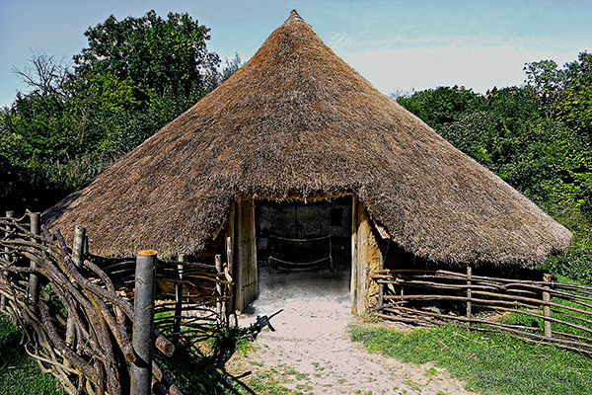

Mrs Applewhite and the EYFS Team

