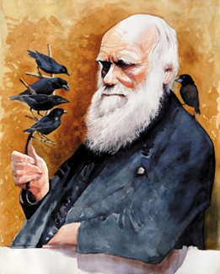
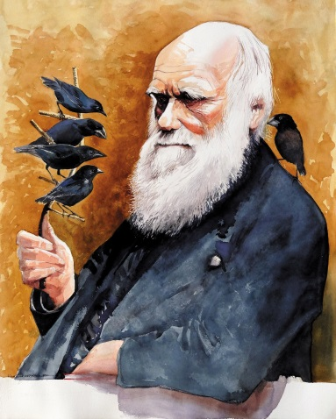
Darwin’s Delights

Eagles Class Newsletter
Spring 1st 2026

Monday 5th January 2026

Dear Parents/Carers of Eagles Class,

Happy New Year! We hope you all had a wonderful Christmas holiday and are feeling rested and ready to take on whatever 2026 throws at us! Mrs Tapley and I would like to thank you all for your generous gifts at Christmas, they were greatly appreciated. This term will be a busy but fun one and we are really looking forward to the interesting learning we have coming up!

This Term’s Learning

We’re off on an exciting expedition with Charles Darwin and his crew on HMS Beagle. Can you trace his route across the vast ocean? Stop at the magical Galápagos Islands to see the amazing species that helped Charles Darwin to develop his theory of evolution by natural selection. Do you know what’s so special about a lava lizard, or why the blue-footed booby has blue feet? See how animals adapt to their environments over time and meet some of the world’s greatest explorers and naturalists.

Home Learning:

This half term we begin preparations for SATs. For home learning, children will receive pages to complete in their SATS workbooks which is to be self-marked (ideally by a parent) by the following Wednesday.

Remember that there are Monday drop-ins where children can bring their books in and ask any homework questions.

Children should be practising their weekly SATS spellings for their Friday tests.

SATS CLUB – Every Tuesday and Thursday there will be a revision session in Eagles until 4.00pm. Tuesday will be focussing on maths and Thursday will be focussing on SPAG, A timetable was sent out before Christmas, as was a slip indicating whether your child will be picked up from school or given permission to leave school alone. These sessions are not compulsory but have proved very successful and useful for past students so I strongly encourage your child to attend.

Reading:

We put a big emphasis on reading in school and ask that this be a real priority at home too. We have fantastic discussions about our class texts in the classroom and the pupils get so much more from their reading if they have time to talk about it.

Please remember to sign the reading diary to show that your child has read 3-5 times in the week and bring this in on a Monday to be checked by teacher.

General:

- Children to arrive at 8:40am to complete Early Morning Work before the register at 8:50am.
- Our PE days are Tuesdays (outdoors) and Fridays (indoors) – please ensure children have the correct kit and footwear. (However, sometimes there are changes to the timetable so PE kits need to be in school all the time)
- No jewellery is to be worn for PE lessons
- Children may wear a watch and a pair of small silver/gold stud earrings for school – no bracelets
- No makeup (including tinted lip balm and nail varnish) is to be worn
- Hair is to be tied up (with an appropriate coloured and sized hairband) at all times during the school day.
- Your child should bring a healthy snack for snack and story time.
- Your child will also need a named bottle filled with water every day.

If you have any questions, you can email me via the school office or catch me at the end of the day.

Here’s to an exciting 2026!

Mrs Suters

