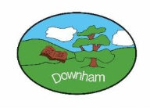
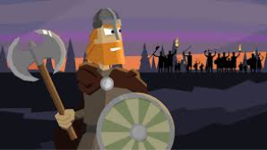
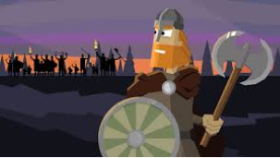

Kingfishers Newsletter
Spring 1st 2026
Dear Parents/Carers of Kingfishers,

We hope you all had a wonderful Christmas break and enjoyed some special time together. Thank you so much for the very kind presents, cards and thoughtful words at the end of last term they were truly appreciated and mean a great deal.

This Half-Term’s Learning
This half term, Year 4 will be stepping back in time as we begin our history topic Clans, Crowns and Kingdoms, focusing on the Anglo-Saxons, Picts and Scots. We will launch our learning with an exciting hook as the children explore the runic alphabet, decoding secret messages just like early settlers once did. Throughout the topic, pupils will work as historians — asking questions, examining evidence and developing a deeper understanding of how these groups lived and settled in Britain. Our learning will culminate in a hands-on Sutton Hoo artefact hunt, where children will apply their knowledge to investigate clues and treasures inspired by one of Britain’s most famous archaeological discoveries.We are looking forward to a half term full of curiosity, creativity and historical adventure!

Home Learning:
- Children will bring home their home learning books on Friday with instructions on activities to be completed. There are 9 topic activities for children to choose from. They should complete one a week alongside the spelling, reading and maths. Books are to be handed in by Wednesday at the latest. Feedback will generally be verbal or a short written comment.
- Spelling will be taught daily. Children are expected to practise these spellings at home via the ‘Spelling Shed’ website.
- Children will be expected to practise their times tables regularly as well using the Times Tables Rockstars app.

Reading:
- Children will be expected to read to/with an adult at home at least 5 times a week. This is to be recorded in your diary which will be checked frequently. Please note that it is absolutely fine for your child to record their reading, however we ask that you then sign their diary over the weekend ready to be handed in on a Monday.
- Reading sessions will happen daily and practise a number of reading skills.
- Children will have a ‘levelled’ reading book for when they are reading with an adult in school. Children will have access to other books in the classroom and library that they are welcome to take home to read.

General:
- Children do not need to bring in stationery, however, they may like to bring in a small pencil case of colouring pencils to keep in their tray. Some children also prefer to have their own glue stick and whiteboard pen. Please ensure that these are labelled so the children know what belongs to them.
- Our PE days are Tuesdays and Fridays please ensure children have the correct kit and footwear. (However, sometimes there are changes to the timetable so PE kits need to be in school all the time).
- No jewellery is to be worn for PE lessons
- Children may wear a watch and a pair of small silver/gold stud earrings for school – no bracelets
- No makeup (including tinted lip balm and nail varnish) is to be worn
- Hair is to be tied up (with an appropriate coloured and sized hairband) at all times during the school day.
- Your child should bring in a snack to enjoy during story time. This may include: a piece of fruit or vegetable, plain crackers, hummus, unprocessed cheese or plain rice cakes. A copy of the school snack policy can be found on the school website.
- Your child will also need a named bottle filled with water every day. They will be able to access and refill their water bottle throughout the day.
- A reminder that if you know that someone different will be collecting your child, please inform the school office who will get the message to us.

Should you have any questions, please feel free to write a note in your child’s reading diary, send an email via the school office (office@downham-ceap.essex.sch.uk) or catch us at the end of the day once all the children have been collected.

Kind regards,

Mrs Crook and Mrs Chapple


