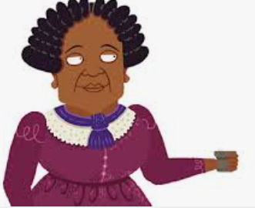
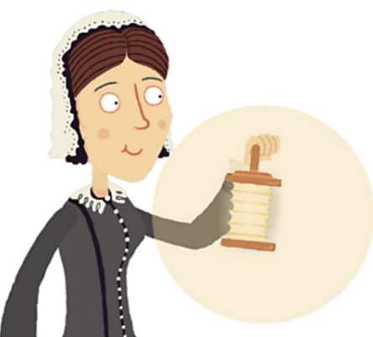

The Lady with the Lamp.
Spring 1st 2026

Dear Parents/Carers of Nightingales Class,

I would firstly like to wish you all a Happy New Year and thank you for your cards and gifts - they are very much appreciated.

This Half-Term’s Learning
Our topic this half term is called ‘The Lady with the Lamp’’. We will be learning about Florence Nightingale and Mary Seacole.
To ‘hook’ the children into the topic, we will be making a Fanoos (Turkish lantern) similar to those by Florence Nightingale during the Crimean War.

Home Learning:
- Children will bring home their home learning books on Friday with instructions on activities to be completed. Books are to be handed in by Wednesday at the latest. Feedback will generally be verbal or a short-written comment.

- Downham has signed up to ‘Times Tables Rock Stars’! Times tables are the essential building blocks that underpin every maths curriculum, yet children always find them a challenge. Times Tables Rock Stars is a maths programme that takes all the worry out of learning times tables and has a proven track record of boosting children’s fluency and recall in multiplication and division. Login details will be given to your child via their reading diary and home learning book on Friday. Children will be expected to practise regularly – ideally daily. For your information, by the end of year 2, children will be expected to know: x2, x5 and x10 times tables.
Reading:
- Reading diaries are to be brought into school every day.

- Please read with you child at least 20 minutes per day. Children read daily to an adult during RWI sessions in school. Please use the week to re-read the book, asking questions about what happens in the story, favourite pictures and why etc. Re-reading the same books helps children with fluency and their understanding of the text.

- Your child will bring different sorts of books home from school. Some books may be story/picture books from our book corner that the children enjoy listening to for you to share. Other books will be the storybooks that are a part of the RWI program. They will also bring home a levelled book with sounds and words they know – a decodable book – so they should be able to read the words.

General:
- A gentle reminder about book bags - our cloakroom cannot accommodate backpacks.
- Children do not need to bring in stationery, everything they need will be available within the classroom.
- Our PE days this term are Wednesday and Thursday – please ensure children have the correct kit and footwear. (However, sometimes there are changes to the timetable so PE kits need to be in school all the time).
- No jewellery is to be worn for PE lessons
- Children may wear a watch and a pair of small silver/gold stud earrings for school – no bracelets
- No makeup (including tinted lip balm and nail varnish) is to be worn
- Hair is to be tied up (with an appropriate coloured and sized hairband) at all times during the school day.
- Your child should bring in a snack to enjoy during morning break. This may include: a piece of fruit or vegetable, plain crackers, hummus, unprocessed cheese or plain rice cakes. A copy of the school snack policy can be found on the school website.
- Your child will also need a named bottle filled with water every day. This will be kept in a tray at the back of the classroom. They will be able to access and refill their water bottle throughout the day.
- A reminder that the children will be dismissed from the classroom at the end of the school day. If you know that someone different will be collecting your child, please inform the school office who will get the message to us.
Should you have any questions, please feel free to write a note in your child’s reading diary, send an email via the school office (office@downham-ceap.essex.sch.uk) or catch me at the end of the day once all the children have been collected.
Kind regards,
Mrs Bennett


