Owls
Spring 1st 2026



Dear Parents/Carers of Owls,

I hope that you had a wonderful Christmas and New Year. Thank you for all your kindnesses and generosity at the end of last term; it was much appreciated.

This Half-Term’s Learning
Our topic this half-term is called “To Boldy Go”. Our topic is primarily science-themed with a focus on Earth and Space. We will be learning about Earth’s place in the solar system, relative to the sun, moon and other planets. We will be exploring how ideas about the solar system have changed over time. We will consider the achievements of humankind in the field of space exploration. Finally, we will complete our topic with a look at the benefits and ethics of future exploration.

To ‘hook’ the children into the topic, we are going to use oil pastels to create a piece of solar system artwork. This will help us to understand the movement of the Earth and other planets relative to the sun in the solar system. Our topic outcome will be a class trip to Southend Planetarium on Wednesday 4th February 2026. There will be an additional email / letter about this trip.

Home Learning:
- Children will bring home their home learning books on Friday.
- Books are to be handed in by Wednesday at the latest. Feedback will be given verbally during the Homework Celebration on Fridays.
- Spelling will be taught daily. Children are expected to practise these spellings at home via the ‘Spelling Shed’ website. The children will also do ‘speedy spellings’ on a daily basis; this will be an opportunity to revise KS1 and Lower Key Stage 2 keywords.
- Children will be expected to practise their times tables regularly as well. Times Tables Rockstars is a great way to practise times tables, although there are other apps and games available too! Or, perhaps you would like to work together to create a new times tables game.

Reading:
- Children should be reading to/with an adult at home at least 5 times a week. Please make a note of this in the Reading Diary. These diaries should be handed in on Mondays so that they can be signed and reading tracked weekly. Well done to everyone who achieved the ‘50 Reads of Autumn’ 2025!
- In class we will be reading Percy Jackson, the Lightning Thief. Every child will have a copy of the book and there will be opportunities to read aloud together. We will also be using this novel during our Reading sessions to develop our comprehension skills.
- Children will have a ‘levelled’ reading book for when they are reading with an adult in school. Children will have access to other books in the classroom and library that they are welcome to take home to read.

General:
- Children do not need to bring in stationery, although some children may prefer to have their own glue stick and whiteboard pen. Please ensure that these are labelled so the children know what belongs to them.
- Our PE days are Wednesday (outdoor) and Thursday (indoor) – please ensure children have the correct kit and footwear. (However, sometimes there are changes to the timetable so PE kits need to be in school all the time).
- No jewellery is to be worn for PE lessons.
- Children may wear a watch and a pair of small silver/gold stud earrings for school – no bracelets.
- No makeup (including tinted lip balm and nail varnish) is to be worn.
- Hair is to be tied up at all times during the school day.
- Your child should bring in a snack, which they may eat at break time. This may include: a piece of fruit or vegetable, plain crackers, hummus, unprocessed cheese or plain rice cakes. A copy of the school snack policy can be found on the school website.
- Your child will also need a named bottle filled with water every day.
- A reminder that the children will be dismissed from the back playground at the end of the school day. If you know that someone different will be collecting your child, please inform the school office who will get the message to us.

Should you have any questions, please send an email via the school office (office@downham-ceap.essex.sch.uk) or catch me at the end of the day once all the children have been collected.

Kind regards,
This half-term, it would be great to see more children engaging with the home learning opportunities. It is impossible to cover everything related to our topic in school in a 6 week half-term. Home Learning gives children the chance to go further with their studies, exploring their own specific interests within our topic. Our weekly Homework Celebration is a time to inspire each other to soar to new heights.

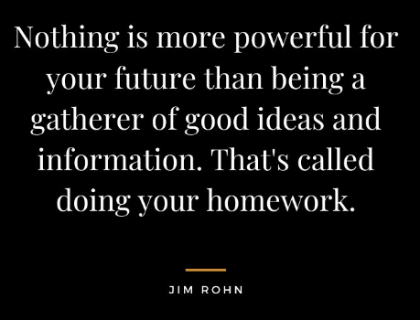
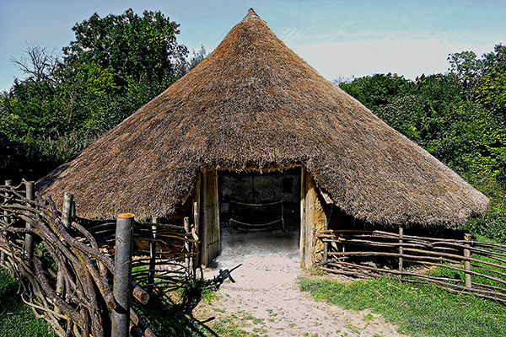

Miss Boyd

