

Ducklings
Autumn 2nd 2025

Dear Parents/Carers of Ducklings,

Welcome back. We hope that you had a lovely half term break full of Autumn walks and fun!

This Half-Term’s Learning


Our topic this half term is called “All the Colours of the Rainbow!” As part of this topic we will be learning about mixing different colours and shades, go on colour walks to experience the changing of the seasons, find out why we celebrate Bonfire Night and Remembrance Day as well as finding out how rainbows are made. We will learn about the importance of light in different festivals.
Christmas
This half term is an extremely busy one as we start our Christmas preparations. Christmas is a fun time at Downham with lots of different things going on. You will no doubt start hearing some of our Christmas Nativity songs soon! Please keep an eye on the weekly newsletter and Class Dojo to be kept up to date with all the Christmas events happening in school.
Adults in Class
I will be in class each day supported by our wonderful Teaching Assistants. Mrs Flood will be in class on a Monday, Tuesday and Wednesday morning. Mrs Waterman will be in class on a Thursday and Friday morning.
Mrs Rivett will be with us each afternoon.
Mrs Dearman will cover my PPA and leadership time.

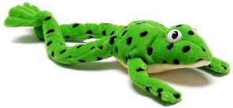

Reading and Home Learning:

- As you are aware, we use the Read, Write, Inc phonics scheme in school to teach phonics and reading. More information about this can be found in your welcome pack and on the school website.
- The children are doing so well learning their sounds with Fred the Frog, using Fred Talk, to help them read new words and using their Fred Fingers to help them spell words.
- This half term, your child will bring home Ditty sheets and Red books to share with you at home.
- The children will continue to bring home a “Have A Go” book (not linked to RWI) to share at home. Please use the week to re-read the book, asking questions about what happens in the story, favourite pictures and why etc. Please record each day you read with your child in the Home/School Diary. Please do not let the reading book replace any time you spend reading stories to your child.
- The children are also free to choose a book form the class library and reading area to read at home. These books can be changed whenever your child is ready. W W

School Dinners

All meals must be pre-ordered (and paid) on the ParentPay website. Class teachers will no longer be taking a lunch register. Any children without a prebooked lunch must have a packed lunch.

General:

- Our PE day is Monday – please ensure children have the correct kit and footwear. (However, sometimes there are changes to the timetable so PE kits need to be in school all the time).
- No jewellery is to be worn for PE lessons. If your child has earrings please make sure these are removed for PE. We are not allowed to remove or cover earrings.
- Please do name all PE kit and all items of uniform, including shoes. We cannot return missing items if they are not named.
- Long hair is to be tied up (with an appropriate coloured and sized hairband) at all times during the school day.
- Our Forest School Day is Thursday. Please ensure appropriate clothing is sent into school on a Thursday morning.
- Your child will need a named bottle filled with water every day. This will be kept in a tray in the classroom. They will be able to access and refill their waterbottle throughout the day.
- Please make sure you are looking out for your child at the end of the day and not on phones etc. Many thanks for your support with this.
- A reminder, if you know that someone different will be collecting your child, please inform the school office who will get the message to us.

Should you have any questions, please feel free to send an email via the school office
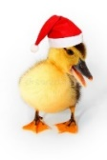
(office@downham-ceap.essex.sch.uk) or catch us at the end of the day once all the children have been collected. We will not be responding to chats sent via Class Dojo – thank you for your support with this.

Here is to a happy and exciting half term!
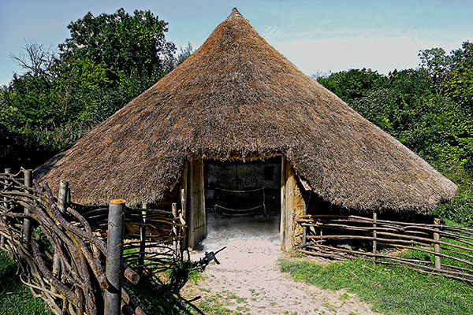
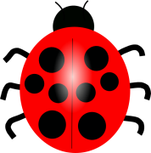
Mrs Applewhite and the EYFS Team

