Owls
Autumn 2nd 2025


Over the Sea & Far Away
Dear Parents/Carers of Owls,

I hope that you had a lovely summer and enjoyed spending some time together as a family. Thank you for all your kindnesses and generosity at the end of last year; it was much appreciated.

This Half-Term’s Learning
Our topic this half-term is called Over the Sea & Far Away. We will be learning about the Mayflower – it’s passengers, their motivations, the voyage, outcome and legacy. There will be a focus on our local History and the connection between Billericay and the Mayflower.

To ‘hook’ the children into the topic, we will be investigating the Mystery of Roanoke Island, and trying to discover what happened to the colonists who vanished. Did they simply die from natural causes? Did they flee from disease or danger? Or were they captured? For our topic ‘outcome’ we will be exploring the traditions around Thanksgiving, including some cooking with Mrs Bennett.

Home Learning:
- Books are to be handed in by Wednesday at the latest. We will have a “Homework Celebration” every Friday, when each child is expected to present his/her Home Learning. Feedback will be given verbally.
- Spelling will be taught daily. Children are expected to practise these spellings at home via the ‘Spelling Shed’ website. The children will also do ‘speedy spellings’ on a daily basis; this will be an opportunity to revise KS1 and Lower Key Stage 2 keywords.
- Children will be expected to practise their times tables regularly as well.

Reading:
- Children will be expected to read to/with an adult at home at least 5 times a week. This is to be recorded in your diary which will be checked and signed on a Monday.
- There is a half-term Class Reading Challenge. Every child should try to read 6 books this half-term. Reading Challenge cards should be brought into school on Mondays.
- In class we will be continuing to read “Charlie and the Chocolate Factory”. Every child has a school copy of the book and there are opportunities to read aloud together. We will also be using this novel during our Reading sessions to develop our comprehension skills.
- Children should have a ‘levelled’ reading book for when they are reading with an adult in school. Children will have access to other books in the classroom and library that they are welcome to take home to read.

General:
- Children do not need to bring in stationery, although some children may prefer to have their own glue stick and whiteboard pen. Please ensure that these are labelled so the children know what belongs to them.
- Our PE days are Wednesday (outdoor) and Thursday (indoor) – please ensure children have the correct kit and footwear. (However, sometimes there are changes to the timetable so PE kits need to be in school all the time).
- No jewellery is to be worn for PE lessons.
- Children may wear a watch and a pair of small silver/gold stud earrings for school – no bracelets.
- No makeup (including tinted lip balm and nail varnish) is to be worn.
- Hair is to be tied up at all times during the school day.
- Your child should bring in a snack, which they may eat at break time. This may include: a piece of fruit or vegetable, plain crackers, hummus, unprocessed cheese or plain rice cakes. A copy of the school snack policy can be found on the school website.
- Your child will also need a named bottle filled with water every day.
- A reminder that the children will be dismissed from the back playground at the end of the school day. If you know that someone different will be collecting your child, please inform the school office who will get the message to us.

Should you have any questions, please feel free to write a note in your child’s reading diary, send an email via the school office (office@downham-ceap.essex.sch.uk) or catch me at the end of the day once all the children have been collected.

Kind regards,


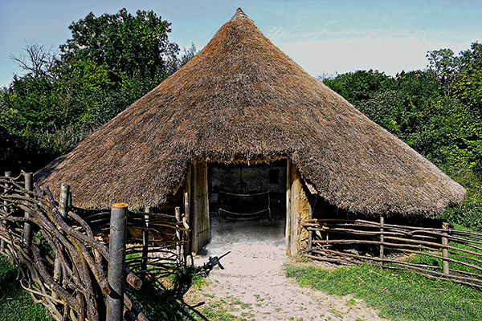

Miss Boyd
Thank you for coming along to our Tudor-themed Rise & Shine Assembly at the end of last half-term. We appreciate your support and encouragement.
Thank you also attending Parent/Teacher meetings. It’s great to be able to work together to support your child/ children to soar to new heights!

