
Ducklings
Autumn 1st 2025

Dear Parents/Carers of Ducklings,

Welcome to Downham. We hope that you had a restful and enjoyable summer break.
We are very excited for the year ahead and cannot wait to get to know you.

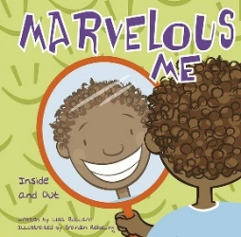
This Half-Term’s Learning

Our topic this half term is called “Marvellous Me”

RWI phonics | Set 1 sounds, reading and writing. Blending simple CVC words
Maths | Getting to know you | Match, sort and compare | Measure and patterns | It’s me 1,2, 3 | Consolidation

Our topic this half term is called “Marvellous Me!” This topic will allow us to make new friends, learn about the school routines as well as finding out about how we grow and develop. It teaches children about being helpful, kind and thoughtful at home and at school. This topic also teaches children how they are unique and special, the importance of friendship and how people in their family, school and local community are important and can help them.

Adults in class this term
Mrs Flood will be with us 3 mornings a week and Mrs Rivett will be with us 4 afternoons a week. Mrs Dearman will be with all day Friday and will cover my PPA time on a Tuesday.
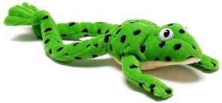

Reading and Home Learning:

- We use the Read, Write, Inc scheme in school to teach phonics and reading. More information about this can be found in your welcome pack and on the school website. Once we start our phonic sessions, your child will bring home sheets and books to share with you at home. The children will also bring home a “Have A Go” book (not linked to RWI) to share at home. Please use the week to re-read the book, asking questions about what happens in the story, favourite pictures and why etc. Please record each day you read with your child in the Home/School Diary. Please do not let the reading book replace any time you spend reading stories to your child.

- The children are also free to choose a book form the class library and reading area to read at home. These books can be changed whenever your child is ready.
- Children will start their home learning in the second half of this half term. This half term we will send home some practical learning activities to share together.

School Dinners

Please remember: All meals must be pre-ordered (and paid) on the ParentPay website. Class teachers will no longer be taking a lunch register. Any children without a prebooked lunch must have a packed lunch.

The children can get very upset if a lunch has not been ordered or they do not know what they are having.

General:

- Children do not need to bring in any stationery. Everything will be provided for them.
- Our PE days are on a Monday this half term– please ensure children have the correct kit and footwear. (However, sometimes there are changes to the timetable so PE kits need to be in school all the time).
- No jewellery is to be worn for PE lessons
- Please do name all PE kit and all items of uniform, including shoes. We cannot return missing items if they are not named.
- Forest School Day is Thursday – please see separate letter
- No makeup (including tinted lip balm and nail varnish) is to be worn
- Hair is to be tied up (with an appropriate coloured and sized hairband) at all times during the school day.
- Your child will need a named bottle filled with water every day. This will be kept in a tray in the classroom. They will be able to access and refill their water bottle throughout the day.
- You can find us on the gate most afternoons after school should you need a quick chat. If you require a longer meeting with us to discuss concerns or issues regarding your child please make an appointment by contacting the school office.
- If you are running late in the morning – as we all do from time to time, please don’t worry! Take your child to the school office and Mrs Doyle will help them to find their way to the classroom.
- Please do not try to send them straight in via the blue gate – if, for some reason, we are not in the classroom, this could be very distressing for your child!
- We know it is very tempting to stay and try to look through the windows at drop off in the morning and also to try and have a sneaky peek at the end of the day. Please do not do this. It can be very upsetting for the children and it also stops them from concentrating on what they should be doing.
- At pick up time please stand back from the gate, on the playground. The children will be encouraged to look for who is picking them up and they cannot do this if everyone is crowding near the gate. Please make sure you are looking out for your child and not on phones etc. Many thanks for your support with this.
- A reminder, if you know that someone different will be collecting your child, please inform the school office who will get the message to us.

Should you have any questions, please feel free to send an email via the school office
(office@downham-ceap.essex.sch.uk) or catch us at the end of the day once all the children have been collected.

Here’s to a happy, fun and exciting first half term in school!

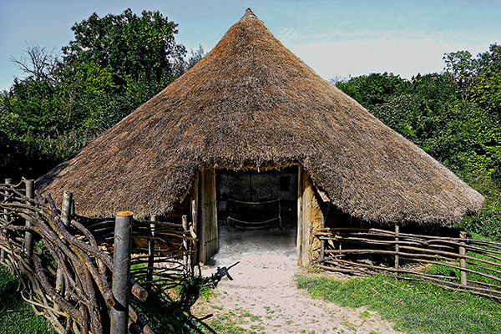

Mrs Applewhite and the EYFS Team


