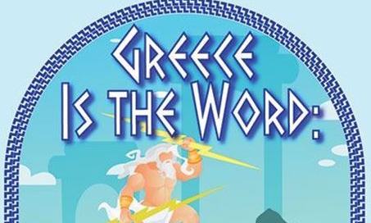

Eagles
Autumn 1st 2025

Dear Parents/Carers of Eagles,

I hope you all had a glorious summer holiday and that the children had a well –deserved break. I’m so excited for the start of the new year and working with your children as they embark on their last year at Downham.

This Half-Term’s Learning
Our topic this half-term is called ‘Greece is the Word’ and will focus on the life and times of Ancient Greece.
To ‘hook’ the children in, we will be competing in a range of Greek themed activities and our ‘outcome’ will be to create a Greek 3D model.

Home Learning:
- Children will bring home their home learning books on Friday with instructions on activities to be completed. There are 9 topic activities for children to choose from. They should complete one a week alongside the spelling, reading and maths. Books are to be handed in by Wednesday at the latest. Feedback will generally be verbal or a short written comment.
- Spelling will be taught daily. Children are expected to practise these spellings at home via the ‘Spelling Shed’ website. The children will also do ‘speedy spellings’ daily, where we will revise KS2 words and Y5/6 words and spelling rules.
- Children will be expected to practise their times tables regularly as well. We will be continuing with Times Tables Rockstars this year and children should be practising regularly as part of their home learning.

Reading:
- Reading diaries are to be brought into school every day.
- Children will be expected to read to/with an adult at home at least 5 times a week. This is to be recorded in your diary which will be checked and signed on a Monday. If your child has read 5 or more times, they will be given a sticker. Please note that it is absolutely fine for your child to record their reading, however we ask that you then sign their diary over the weekend ready to be handed in on a Monday.
- Whole class reading sessions will happen daily, where children will each have a copy of the class text. Children will read 1:1 with an adult as regularly as possible. In addition to this, children will have opportunities to listen to an adult read as well as reading to themselves.
- Children will have a ‘levelled’ reading book for when they are reading with an adult in school. Children will have access to other books in the classroom and library that they are welcome to take home to read.

General:
- Children do not need to bring in stationery, however, they may like to bring in a small pencil case of colouring pencils to keep in their tray. Some children also prefer to have their own glue stick and whiteboard pen. Please ensure that these are labelled so the children know what belongs to them.
- Our PE days are Tuesday and Wednesday – please ensure children have the correct kit and footwear. (However, sometimes there are changes to the timetable so PE kits need to be in school all the time).
- No jewellery is to be worn for PE lessons
- Children may wear a watch and a pair of small silver/gold stud earrings for school – no bracelets
- No makeup (including tinted lip balm and nail varnish) is to be worn
- Hair is to be tied up (with an appropriate coloured and sized hairband) at all times during the school day.
- Your child should bring in a snack to enjoy during story time. This may include: a piece of fruit or vegetable, plain crackers, hummus, unprocessed cheese or plain rice cakes. A copy of the school snack policy can be found on the school website.
- Your child will also need a named bottle filled with water every day. This will be kept in a tray at the back of the classroom. They will be able to access and refill their water bottle throughout the day.
- A reminder that the children will be dismissed from the classroom at the end of the school day. If you know that someone different will be collecting your child, please inform the school office who will get the message to us.

Should you have any questions, please feel free to write a note in your child’s reading diary, send an email via the school office (office@downham-ceap.essex.sch.uk) or catch us at the end of the day once all the children have been collected.

Kind regards,

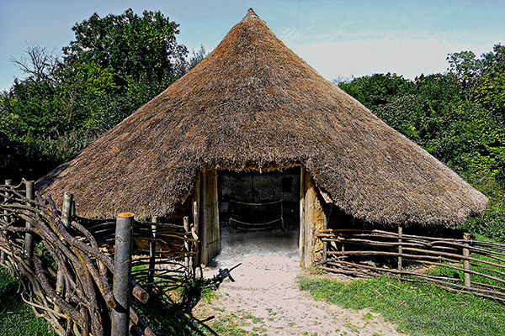
Mrs Suters


