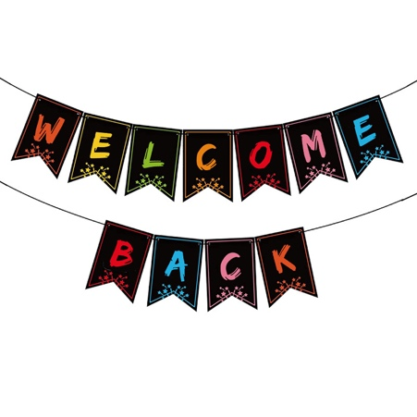
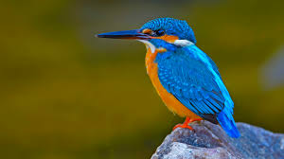

Kingfishers
Autumn 1st 2025

Dear Parents/Carers of Kingfishers Class,

Welcome back! I hope that you all had a wonderful summer holiday and managed to enjoy some sun, time with family and friends and a well-deserved rest! Mrs Chapple and I are very excited to be teaching your child this academic year. This half-term we have a lot to fit in, including a class trip to the British Museum on Friday 17th October to finish our topic on Ancient Egypt. I am so excited about this; I still fondly remember my trip there when I learnt about the Egyptians in primary school and I hope this trip leaves lifelong memories for Kingfishers too! Keep an eye out for the letter about this coming home with the children very soon!

This Half-Term’s Learning
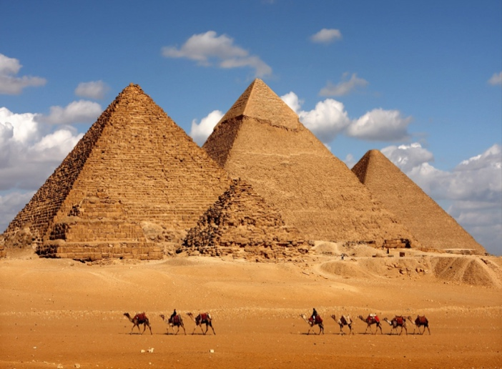
Our topic this half-term is called ‘Tomb Raiders’. In this topic, we will be going back in time to explore the Ancient Egyptian civilisation. We will be exploring the human and physical geography of modern Egypt, making comparisons with England, as well as diving into the rich and fascinating history of Ancient Egypt where we will learn about situating the civilisation on a history timeline, the social ranking of individuals in Ancient Egypt, famous pharaohs, their belief system (Gods and Goddesses), the importance of pyramids and inventions and achievements of Ancient Egypt.

For more information about what will be taught in every subject this half-term, please refer to the Topic Overview.

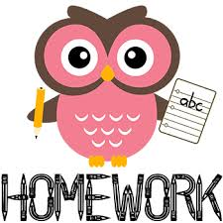
Home Learning:
- Children will bring home their red Home Learning books on Friday with instructions on activities to be completed for the following week. These books are to be handed in by Wednesday at the latest. Feedback will generally be verbal or a short-written comment.
- Spelling will be taught daily in class. Children are expected to practise these spellings at home via the ‘Spelling Shed’ website and they also have their weekly spellings on a label stuck in their reading diary.
- Children will be expected to practise their times tables regularly on Times Tables Rockstars. This is part of their home learning. If, however, children prefer to practise using a different method, that is absolutely fine, but please write us a short message in your child’s Home Learning book or diary to let us know as we do check weekly to see who is logging on to play.
- Each child is expected to complete Topic home learning. There are lots of creative and different ideas to choose each week and we look forward to sharing the home learning in class. Please see the grid stuck into your child’s Home Learning books for more information.


Reading:
- Children will be expected to read to/with an adult at home at least 5 times a week. This is to be recorded in their reading diary which will be checked and signed on a Monday.
- Guided reading sessions, where children will have the opportunity to read and discuss a text with an adult and/or their peers in a group, will take place weekly. Children will read 1:1 with an adult as regularly as possible. In addition to this, children will have opportunities to listen to an adult read as well as reading to themselves.
- Children will have a ‘levelled’ reading book for when they are reading with an adult in school. Children will have access to other books in the classroom and library that they are welcome to take home to read.

General:
- Children do not need to bring in stationery, however, they may like to bring in a small pencil case of colouring pencils to keep in their tray. Some children also prefer to have their own glue stick and whiteboard pen. Please ensure that these are labelled so the children know what belongs to them.
- Our PE days are Tuesday and Friday – please ensure children have the correct kit and footwear. (However, sometimes there are changes to the timetable so PE kits need to be in school all the time).
- No jewellery is to be worn for PE lessons
- Children may wear a watch and a pair of small silver/gold stud earrings for school – no bracelets
- No makeup (including tinted lip balm and nail varnish) is to be worn
- Hair is to be tied up (with an appropriate coloured and sized hairband) at all times during the school day.
- Your child should bring in a snack to enjoy during story time. This may include: a piece of fruit or vegetable, plain crackers, hummus, unprocessed cheese or plain rice cakes. A copy of the school snack policy can be found on the school website.
- Your child will also need a named bottle filled with water every day. They will be able to access and refill their water bottle throughout the day.
- Children will be dismissed from the back playground at the end of the school day. A reminder to please let Mrs Doyle know if someone different will be collecting your child and the message will get sent to us. We will not allow children to go home with a different adult without receiving a message from the school office.

Should you have any questions, please feel free to write a note in your child’s reading diary, send an email via the school office (office@downham-ceap.essex.sch.uk) or catch us at the end of the day once all the children have been collected.

We are incredibly excited for the year ahead and hope you are too!

Kind regards,

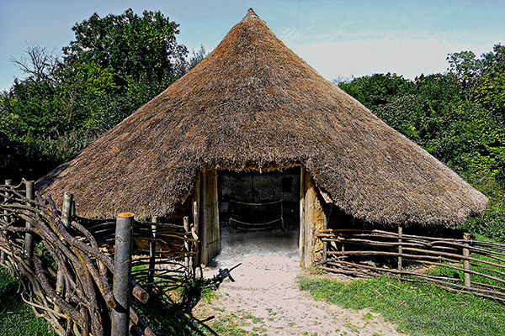

Mrs Crook and Mrs Chapple

