Owls
Autumn 1st 2025

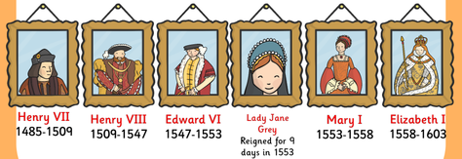

Dear Parents/Carers of Owls,

Welcome to Owls Class & Year 5. It’s going to be a great year with lots of exciting topics and learning opportunities.

This Half-Term’s Learning – Tudors: Trials & Tribulations
This half-term Owls will be investigating the Tudors, staring with a look at the War of the Roses and how Henry Tudor became king of England. We will take a look at Henry VIII and how Hans Holbein (the great portrait artist) played an important role in creating the king we now know. Which of Henry VIII’s wives was the most significant? We’ll find out! We will also be looking at other key events during his reign (the translation of the Bible into English, the break with the Catholic Church and the dissolution of the monasteries). From there, we will go on to study the reigns of Henry VIII’s children, and Lady Jane Grey! Where does Mary Queen of Scots fit in? What was the Spanish Armada and can it really be considered a turning point in British History?

Our topic hook will be an investigation into the mystery of the Princes in the Tower and how Henry Tudor came to power. For our topic outcome, we would like to invite parents / carers to a special Rise & Shine Assembly on Friday 24th October 2025 at 9.15am.

Home Learning:
- Children will bring home their home learning books on Friday.
- Books are to be handed in by Wednesday, ready for our Homework Celebration on Fridays. Feedback will be given verbally as each child presents his/her homework.
- Spelling will be taught daily. Children are expected to practise these spellings at home via the ‘Spelling Shed’ website. The children will also do ‘speedy spellings’ on a daily basis; this will be an opportunity to revise KS1 and Lower Key Stage 2 keywords.
- There will be a Spelling Homework sheet to be completed each week. These sheets will all be glued into Home Learning books at the start of the half-term but should be completed weekly, as new spellings are assigned. We will mark them together, as a class, on Fridays.
- Children will be expected to practise their times tables regularly as well. Times Tables Rockstars is particularly useful for this and children should aim to complete 5 x 10 minute sessions each week.

Reading:
- Reading diaries are to be brought into school every day; they will be checked on Mondays.
- Please read with your child at home, ideally at least 4 times per week. This should be recorded in your child’s Reading diary.
- Children should continue to work on completing the 40 Book Reading Challenge.
- Children should have a ‘levelled’ reading book for when they are reading with an adult in school. Children will have access to other books in the classroom and library that they are welcome to take home to read.

General:
- Children do not need to bring in stationery, although some children may prefer to have their own glue stick and whiteboard pen. Please ensure that these are labelled so the children know what belongs to them.
- Mrs Cronin will be with us on Tuesdays and Wednesdays. Mrs Dearman will cover my PPA (Planning, Preparation and Assessment) time on Tuesday afternoons.
- Our PE days are Wednesday and Thursdays – please ensure children have the correct kit and footwear. As our PE timetable slots are last thing in the afternoon (2.15 – 3.15) children will be going home in their PE kits. Please make sure that PE kits are brought back to school the following day as our PE sessions are on consecutive days.
- No jewellery is to be worn for PE lessons.
- Children may wear a watch and a pair of small silver/gold stud earrings for school – no bracelets.
- No makeup (including tinted lip balm and nail varnish) is to be worn.
- Hair is to be tied up at all times during the school day.
- Your child should bring in a snack, which they may eat at break time. This may include: a piece of fruit or vegetable, plain crackers, hummus, unprocessed cheese or plain rice cakes. A copy of the school snack policy can be found on the school website.
- Your child will also need a named bottle filled with water every day.
- Year 5 children will be dismissed from the back playground at the end of the school day. If you know that someone different will be collecting your child, please inform the school office who will get the message to us.

Should you have any questions, please feel free to write a note in your child’s reading diary, send an email via the school office (office@downham-ceap.essex.sch.uk) or catch me at the end of the day once all the children have been collected.

Kind regards,

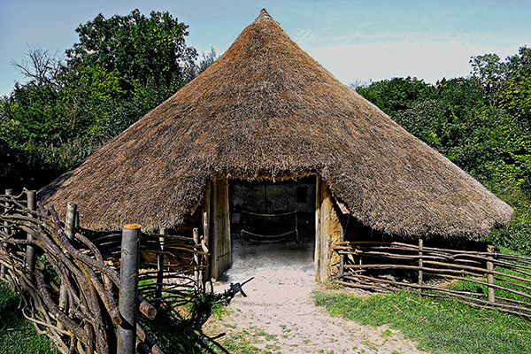
Miss Boyd


