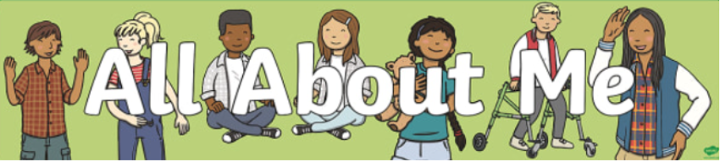

Y1 - Robins
Autumn 1st 2025


Dear Parents/Carers of ROBINS,

Welcome back! We hope that you have had a wonderful summer holiday and looking forward to the new school year.

We will spend time this half-term going through the changes from Reception to KS1 with the children and are confident that they will settle into year 1 really quickly.

Mrs Hollaman will be teaching the class with Miss Kaur supporting each morning. Mrs Dearman will cover PPA time, which will generally be on a Wednesday morning.
This Half-Term’s Learning
Our first topic is called, “All about me”. In this topic, children will celebrate how amazing they are and begin to look at their own history. They will develop an understanding of different families and friendships whilst recognising personal areas of character strengths. They will learn about the human body and how we use our senses. In Art, children will be create spirals based on the work from Molly Haslund and in music they will be focusing on keeping a pulse with different parts of the body.

To ‘hook’ the children into the topic I am asking if parents/carers could send in a baby picture of their child in a sealed envelope addressed to me so that we play ‘Guess Who’ as a class.

Home Learning:
- Children will bring home their home learning books on Friday. Please choose one activity per week to complete from the home learning grid. Books are to be handed in by Wednesday at the latest. Feedback will generally be verbal or a short-written comment. Children will have the opportunity to ‘show and tell’ their home learning with the class on a Friday.

Reading:
- Children should bring their reading diary and reading book into school every day. Children will be expected to read to/with an adult at home at least 5 times a week. This is to be recorded in your diary which will be checked and signed on a Monday.
- Our Read Write Inc. Phonics sessions will take place every day. Your child will bring home a phonics reading book on Wednesday, which we would like them to read to you. RWI books include the specific sounds and words they will be learning during that week so reading this book with you at home is paramount to their progress in phonics. Encourage children to use their “Fred Talk” when sounding out words. Please return this book on Friday.
- Children will also be given a levelled reading book which we will aim to change twice per week - on Mondays and Fridays. These books open your child to a wider range of vocabulary and enable them to put their phonics learning into practise. Aim to read these books more than once with your child over the week.
- Children will read daily to an adult during the RWI session and 1:1 with a teacher or teaching assistant as regularly as possible. In addition to this, children will have opportunities to listen to an adult read as well as reading to themselves.
- Children will have a ‘levelled’ reading book and will have access to other books in the classroom/library to take home as well.
- Regularly read to your child at bedtime - research proves that reading with an adult greatly benefits their literacy skills.
- General:
- Our PE days are Tuesday and Thursday – please ensure children have the correct kit and footwear. (However, sometimes there are changes to the timetable so PE kits need to be in school all the time). Please ensure all PE kit and school uniform is labelled clearly with your child’s name.
- No jewellery is to be worn for PE lessons. If your child cannot take out their earrings on their own, please remove these before school.
- Children may wear a watch and a pair of small silver/gold stud earrings for school – no bracelets or necklaces.
- No makeup (including tinted lip balm and nail varnish) is to be worn
- Hair is to be tied up (with an appropriate coloured and sized hairband) at all times during the school day.
- Your child will also need a named bottle filled with water every day. This will be kept in a tray at the back of the classroom. They will be able to access and refill their water bottle throughout the day.
- Children will come in and out of school via the blue gate. In the morning, please say goodbye at the blue gate and let your child walk independently down to the door which opens at 8.45am. Registration is at 8.55am. Children need to in, unpacked and ready by 8.55am.
- If you have a message for me, please inform the member of staff on the gate who will pass it on. At the end of the day (3.15pm) please come and wait by the classroom door where I will dismiss the children 1 by 1. It would be helpful if you give us a wave! If you know that someone different will be collecting your child, please inform the school office who will get the message to me.
- Children should wear black school shoes or plain black trainers to school every day.
- Your child will also need a named bottle filled with water every day. This will be kept in a tray at the back of the classroom. They will be able to access and refill their water bottle throughout the day. Space is limited therefore please ensure that bottles are appropriately sized e.g. 500ml.

Should you have any questions, please feel free to write a note in your child’s reading diary, send an email via the school office (office@downham-ceap.essex.sch.uk) or catch me at the end of the day once all the children have been collected.

I look forward to meeting you soon.

Kind regards,
Mrs Hollaman

