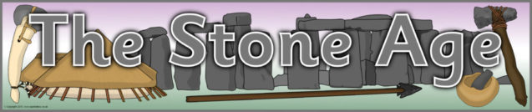

Y3 - Woodpeckers
Autumn 1st 2025


Dear Parents/Carers of WOODPECKERS,

Welcome back! We hope that you have had a wonderful summer holiday and looking forward to the new school year.

We hope that you enjoyed reading the ‘Woodpeckers’ booklet that was given to your child before the holidays. We will spend time this half-term going through the changes from KS1 and KS2 with the children and are confident that they will settle into year 3 really quickly.

Miss Proctor will teach the class on a Monday, Tuesday, Thursday and Friday and Mrs Chapple will teach the children on a Wednesday during Miss Proctor’s leadership time. Mrs Dearman will cover PPA time, which will generally be on a Thursday afternoon.

This Half-Term’s Learning
Our first topic is called, ‘The Stone Age”. In this topic we will explore the meaning of ‘prehistory’; learn why it was called the Stone Age; when it was and how long it lasted in Britain as well as the different periods during the Stone Age. We will learn about how people lived – their homes, their diet and what they did for fun. Please see the Topic Overview for more information about what else we are learning this half term.

To ‘hook’ the children into the topic we will be making pom pom woolly mammoths. The ‘outcome’ will be to make Stone Age caves using a shoe box. Please keep hold of a small shoe box and bring in the week commencing Monday 20th October. Children will have the opportunity to go outside and look for natural materials, however they are welcome to bring in sticks, stones, clay, moss, leaves etc.

Home Learning:
- Children will bring home their home learning books on Friday. Please choose one activity per week to complete from the home learning grid. Books are to be handed in by Wednesday at the latest. Feedback will generally be verbal or a short-written comment. Children will have the opportunity to ‘show and tell’ their home learning with the class on a Friday.

- Spelling will be taught daily. Children are expected to practise these spellings at home via the ‘Spelling Shed’ website. Login details will be given to the children in the coming weeks. A copy will be put in their reading diary and their home learning book. A copy of the week’s spellings will be put in children’s reading diaries on a Monday. (Please ensure that they are in school).


- Children are expected to practise times tables regularly – ideally daily. Little and often – 3-5 minutes a day will make all the difference. Times tables are the essential building blocks that underpin every maths curriculum, yet children always find them a challenge. Times Tables Rock Stars is a maths programme that takes all the worry out of learning times tables and has a proven track record of boosting children’s fluency and recall in multiplication and division. Login details remain the same as last year, however a copy will be put into children’s reading diaries and home learning books in the coming weeks. The children will have the opportunity to compete against their classmates, other classes and also the staff! The more you practise – the higher your score!
- For your information, by the end of year 3, children will be expected to know: x2, x5, x10, x3, x4 and x8 times tables.

Reading:
- Reading diaries are to be brought into school every day.
- Children will be expected to read at home at least 5 times a week. Ideally, this will be with/to an adult. Reading is to be recorded in your diary which will be checked and signed on a Monday. Staff will record how many times your child has read that week and write it in the box. Please ensure that diaries are completed, signed and ready to be checked on a Monday.
- The aim is to read at least 50 times in a term. Any children who read 50 times or more will be presented with a special certificate at the end of the term.
- Please note that it is absolutely fine for your child to record their reading, however we ask that you then sign their diary over the weekend ready to be handed in on a Monday.
- Children will participate in daily reading sessions, where they will have the opportunity to discuss a book as a whole class. Our class book this half-term is ‘Wreck of the Zanzibar’ by Michael Morpurgo.
- In addition to this, there will be opportunities for the children to read to themselves and 1:1 to an adult with a levelled book. We encourage the children to keep this book in their school bag so that it is always available. Children will have access to other books in the classroom and library that they are welcome to take home to read. Please ensure that books are returned so that others may enjoy them too.

General:
- Children will come in and out of school via the old library door. In the morning, please say goodbye at the brown gate and let your child walk independently down to the door which opens at 8.45am. Registration is at 8.55am. Children need to in, unpacked and ready by 8.55am.
- If you have a message for us, please inform the member of staff on the gate who will pass it on. At the end of the day (3.15pm) please come and wait by the blue gate opposite the classroom door where we will dismiss the children 1 by 1. It would be helpful if you give us a wave! If you know that someone different will be collecting your child, please inform the school office who will get the message to us.
- Children do not need to bring in stationery, however, they may like to bring in a small pencil case of colouring pencils to keep in their tray.
- Our PE days are Monday and Wednesday – please ensure children have the correct kit and footwear. (However, sometimes there are changes to the timetable so PE kits need to be in school all the time).
- No jewellery is to be worn for PE lessons
- Children may wear a watch and a pair of small silver/gold stud earrings for school – no bracelets
- No makeup (including tinted lip balm and nail varnish) is to be worn
- Hair is to be tied up (with an appropriate school-coloured and sized hairband) at all times during the school day.
- Children should wear black school shoes or plain black trainers to school every day
- Your child should bring in a snack to enjoy during breaktime. This may include: a piece of fruit or vegetable, plain crackers, hummus, unprocessed cheese or plain rice cakes. A copy of the school snack policy can be found on the school website. Please label snack pots with your child’s name.
- Your child will also need a named bottle filled with water every day. This will be kept in a tray at the back of the classroom. They will be able to access and refill their water bottle throughout the day. Space is limited therefore please ensure that bottles are appropriately sized e.g. 500ml.

Should you have any questions, please feel free to write a note in your child’s reading diary, send an email via the school office (office@downham-ceap.essex.sch.uk) or catch us at the end of the day once all the children have been collected.

We look forward to meeting you soon.

Kind regards,
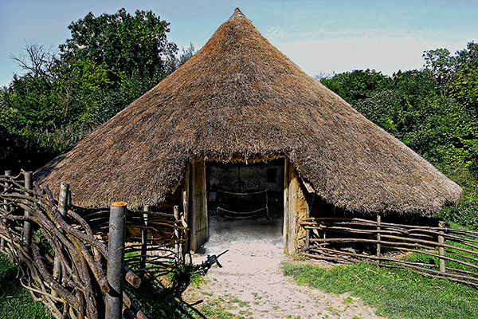
Miss Proctor & Mrs Chapple

