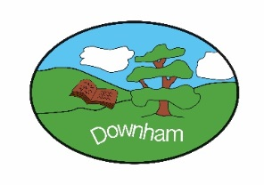
Year 2 Nightingales
Class Novels – Autumn 2
Vlad and the Florence Nightingale Adventure by Kate Cunningham
Florence Nightingales by Maria Isabel Sanchez Vegara
Hoorah for Mary Seacole by Trish Cooke

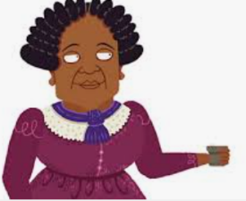
The Lady with the Lamp!
Spring 1st 2026
Topic Overview:
Our topic this term is predominantly history based and will focus on the lives of significant historical figures. We will consider what makes people significant rather than famous. Who is significant to us and why. We will learn about Florence Nightingale and Mary Seacole who disregarded conventions in 19th century in order to help others.
Hook:  Make a Fanoos (Turkish Lamp) similar to the one used by Florence in Scutari. |  |  | Outcome:  Virtual workshop with Florence Nightingale Museum
What’s being covered?

Maths | Geometry, Measure (money), Multiplication and Division
English | Recount, narrative (losing story), poetry
 | Topic | Skills
Science | Living Things  Microhabitats | - Compare the differences between things that are living, dead and things that have never been alive.  - Identify that most living things live in habitats to which they are suited.  - Describe how different habitats provide for the basic needs of different kinds of animals and plants.  - Identify and name a variety of plants and animals in their habitats, including microhabitats.  - Describe how animals obtain their food from plants and other animals using the idea of a simple food chain.
History | The Lady with the Lamp | - Events beyond living memory that are significant nationally and globally.  - Understand the methods of historical enquiry  - The lives of significant individuals in the past who have contributed to national and international achievements.
DT | Textiles: Pouches | - Prepare and cut fabric to make a pouch from a template.  - Use a running stitch to join the two pieces of fabric together.  - Decorate their pouch using the materials provided.
Music | Charanga Music  I wanna play in a band. | - Rock music  - Listen and appraise music from this genre
Computing | Programming Robot Algorithms | To develop understanding of instructions in sequences and the use of logical reasoning to predict outcomes.
PSHE | Safety and the changing body. | - Understand how the internet can be used to help us.  - Understand what a secret is and what a surprise is.  - Know the name of parts of the body, including those of the private parts for their gender.  - Understand how to keep safe near roads.  - Understand when we should take medicines that can help us feel better when we are unwell.
RE | Big Question: How do Christians belong to their faith family | - Identify how Christian’s beliefs impact on their worship and sense of belonging. · Identify some Christian symbols and artefacts.  - Identify different ways in which Christians show they belong to their faith family. ·  - Recognise that some people call themselves Christians.
PE | Gymnastics  Sending and receiving | - To develop basic gymnastic actions on the floor and using apparatus.  - To work safely with and around others.  - To provide feedback.  - To roll, track, catch, and receive with feet. ·  - To send and receive with a racket.  - To communicate and collaborate with others

