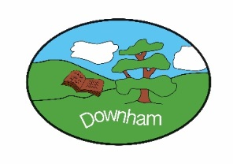
Year 5 – Owls

Spring 1st 2026
Topic Overview:
In our TO BOLDLY GO topic, we will have a focus on Earth and Space. We will be learning about Earth’s place in the solar system, relative to the sun, moon and other planets. We will be exploring how ideas about the solar system have changed over time. We will consider the achievements of humankind in the field of space exploration. We will finish our topic with a look at the benefits and ethics of future exploration.

Outcome:

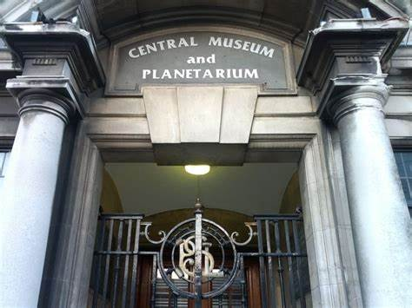
A class trip to Southend Planetarium on Wednesday 4th February 2026.
Hook:
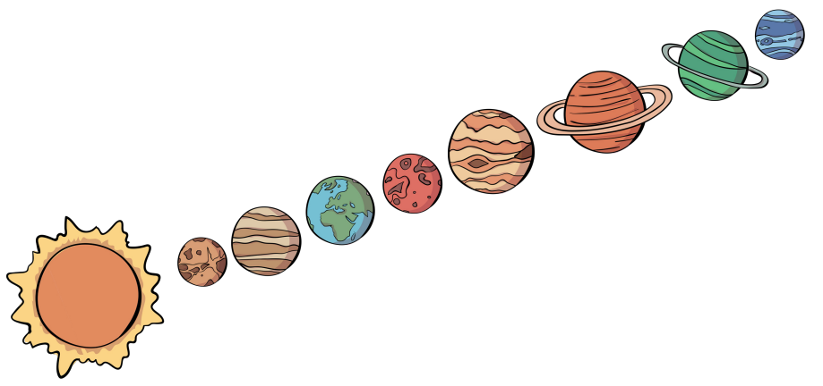
We are going to use oil pastels to complete a piece of Solar System Artwork. This will help us to understand the movement of the Earth and other planets relative to the sun in the solar system.
What’s being covered?
Maths | Multiplication & Division and Fractions
English | Fantasy Narrative (portal stories), autobiography and persuasive letters
 | Topic | Skills
History | To Boldly Go | Chronological Understanding  - accurately use dates and terms to describe historical events  Presenting, Organising & Communicating  - Present, communicate and organise ideas about the past using detailed discussions, debates and more detailed written narratives  Knowledge & Understanding of Events & People in the Past  - Describe the key features of the past, including attitudes, beliefs and the everyday lives of men, women and children  Causes & Consequences  - Understand that the consequences of one historical event can sometimes become the causes of another
Geography | To Boldly Go | Locational Knowledge:  - Identify the position and significance of latitude, longitude, Equator, Northern Hemisphere, Southern Hemisphere and use longitude and latitude to find locations on a map  Geographical Skills & Fieldwork:  - Use maps, atlases, globes and digital / computer mapping to locate countries
DT | Gears & Pulleys | - Give examples of machines that use gears and/or pulleys.  - Describe how gears and pulleys work and their purpose.  - Design and make a gear and pulley system.  - Write a problem statement.  - Write questions for market research, provide feedback and research market competitors.  - Write and use a design brief to guide design.  - Evaluate a product against a set of design criteria, provide useful feedback and incorporate changes.  - Draw and annotate an eco-gadget bike design
Music | Make You Feel My Love | - Play and perform using voices and musical instruments (recorder)  - Improvise and compose music using inter-related dimensions of music  - Listen with attention to detail and recall sounds with increasing aural memory  - Use and understand staff and other musical notations  - Develop an understanding of the history of music
Science | Earth and Space | - Describe the movement of the Earth and other planets relative to the sun in the solar system  - Describe the movement of the moon relative to the Earth  - Describe the sun, Earth and moon as approximately spherical bodies  - Use the idea of the Earth’s rotation to explain day and night and the apparent movement of the sun across the sky
Computing | Data and Information – Flat-file Databases | - use a form to record information  - compare paper and computer-based databases  - outline how you can answer questions by grouping and then sorting data  - explain that tools can be used to select specific data  - explain that computer programs can be used to compare data visually  - use a real-world database to answer questions
PSHE | Belonging to a community Protecting the environment; compassion towards other  Media literacy and Digital resilience | - about how resources are allocated and the effect this has on individuals, communities and the environment  - the importance of protecting the environment and how everyday actions can either support or damage it  - how to show compassion for the environment, animals and other living things  - about the way that money is spent and how it affects the environment  - to express their own opinions about their responsibility towards the environment  - identify different types of media and their different purposes e.g. to entertain,  - inform, persuade or advertise basic strategies to assess whether content online (e.g. research, news, reviews, blogs) is based on fact, opinion, or is biased that some media and online content promote stereotypes  - recognise how to assess which search results are more reliable than others to recognise unsafe or suspicious content online  - recognise how devices store and share information
French | Town and Time | - More Places around Town  - Telling the Time  - Cities of the World
RE | What can we learn about the world/ knowledge/ meaning of life from the great philosophers? | - Explain some of the ways different philosophers or religions understand abstract concepts, including varying views about the existence of the soul in classical Greek Philosophy.  - Explain different philosophical and religious answers to questions about the world around them and the existence of the ‘self’ and or soul.  - Have an understanding of the Analogy of the Cave and what it says about existence and knowledge
Indoor PE | Gymnastics | - Perform symmetrical and asymmetrical balances, including using apparatus  - Develop straight, forward, straddle and backwards roll into a sequence  - Explore different methods of travelling, linking actions in both canon and synchronisation  - Perform progressions of inverted movements  - Explore matching and mirroring sequences on the floor and on apparatus  - Create partner and group sequences using apparatus
Outdoor PE | Netball | - Explore different passes and apply them in different situations  - Develop movement skills to lose a defender  - Communicate with teammates, moving into a space to take the ball towards the goal  - Attack an opponent and know when to try to intercept  - Develop shooting action under pressure

