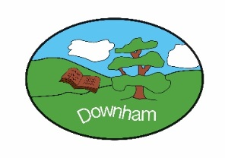
Year 1 - Robins

“Where in the World”
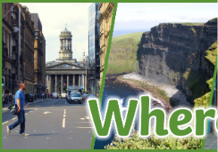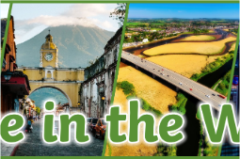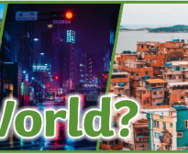
Spring 1st 2026
Our topic for this half of the spring term will be Where in the World. The learning will be driven by exploring the physical world through Science (Everyday Materials) and comparing distant places in Geography (Shanghai vs. UK), all while developing confident communication and numerical fluency.

Outcome:
To explore the physical world around us and understand our wonderful planet Earth. We will compare different places in the world and learn about others.

Hook:
Create a healthy smoothie with fruits and vegetables from all over the world.

What’s being covered?
English | In Year 1, we will become confident writers by focusing on three key areas: writing stories (creating characters and plots), writing recounts (sharing past events in order), and writing instructions (using 'bossy' verbs to explain a task). We will concentrate on developing basic skills like correct letter formation, using finger spaces and remembering to use capital letters and full stops in all our sentences.
Maths | Following our work with numbers up to 10, we now focus on numbers up to 20. We will explore Place Value by learning to identify the tens and ones in numbers like 13 or 19. This foundation is crucial for developing secure strategies for addition and subtraction to 20. We will use number lines and resources to solve problems, ensuring confident fluency across all facts and calculations within the 0-20 range.
Subject | Topic | Skills
Science  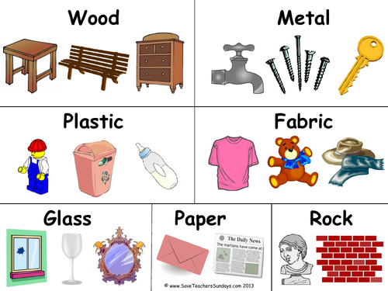 | Everyday materials | - To identify everyday materials  - To sort objects into groups based on the materials they are made from  - To recognise the difference between objects and materials  - To describe properties of materials  - To group materials based on their properties (absorbency, waterproofness and toughness)  - To make observations and record data  - To plan a test and suggest what might happen  - To answer questions based on results
Geography  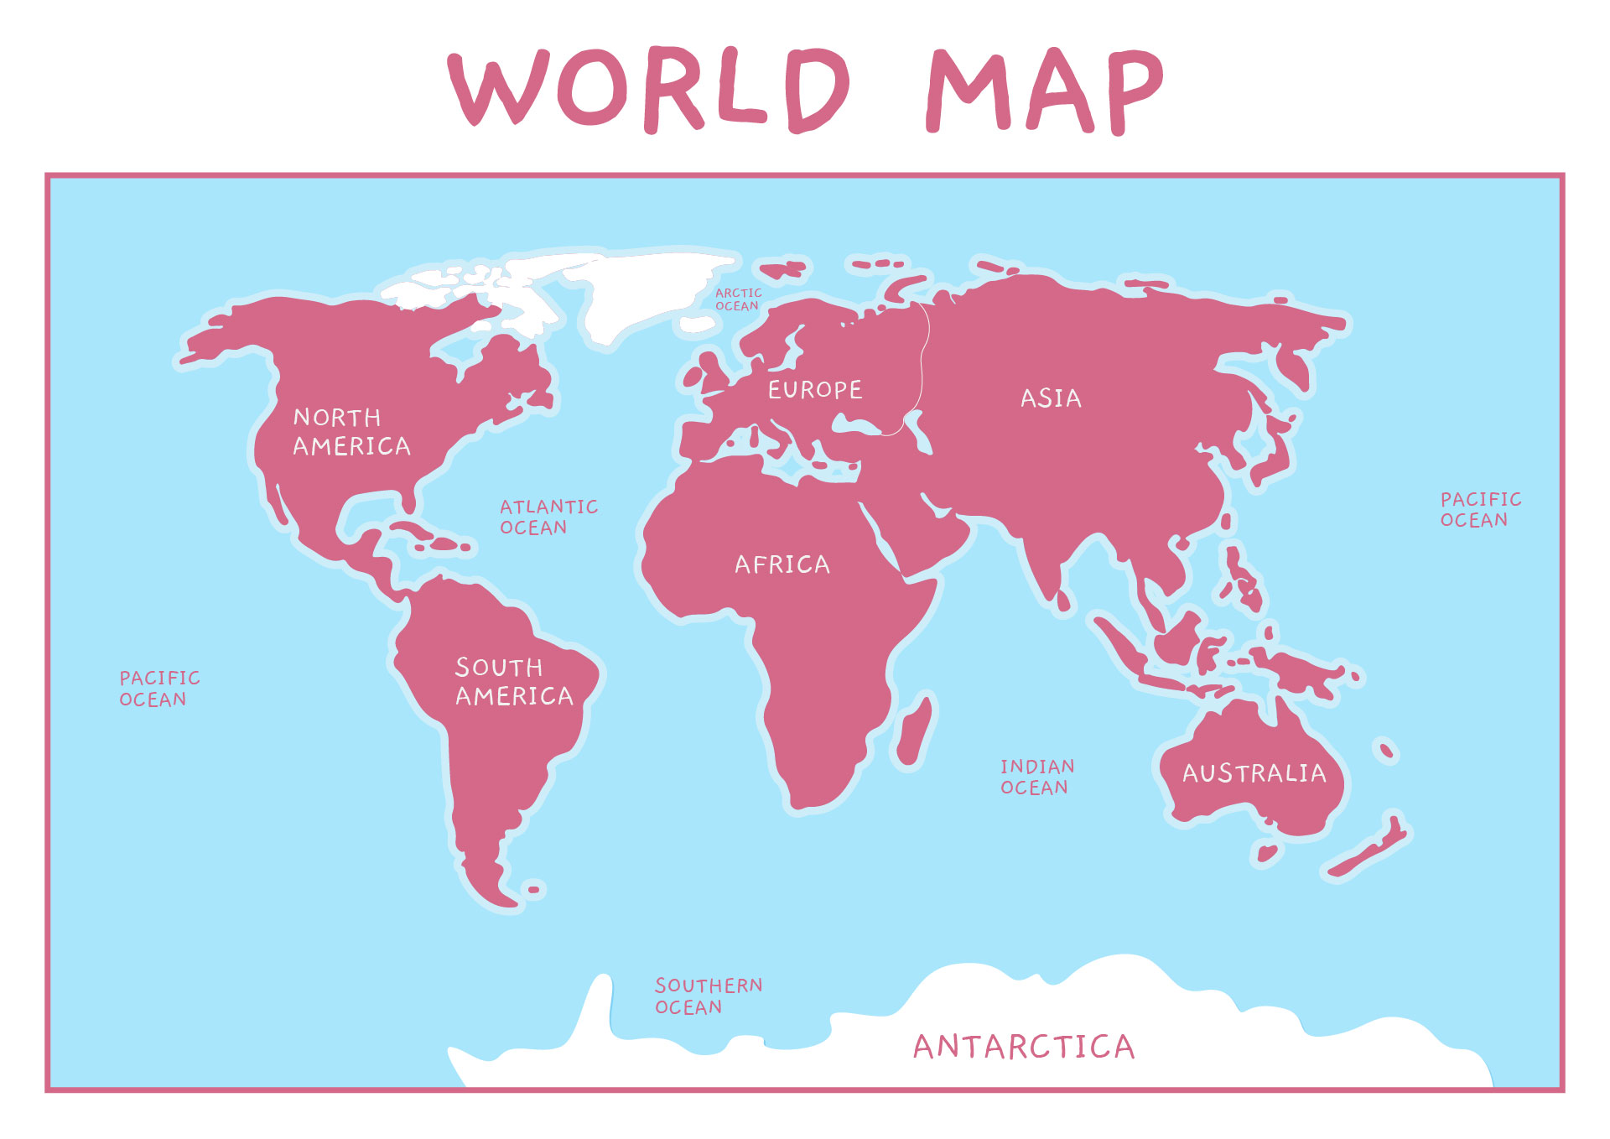 | Physical Geography | - To recognise human and physical features  - To name and locate some continents on a world map  - To identify physical and human features of a non-European country  - To describe what it is like in Shanghai  - To compare Shanghai to a small area of the UK
DT  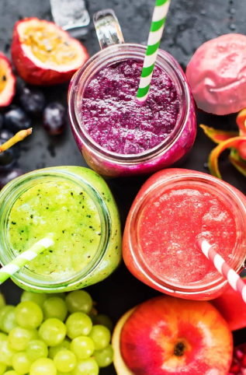 | Cooking & Nutrition: Making smoothies | - To identify fruits  - To describe where fruits and vegetables grow  - To practice food preparation skills  - To select ingredients for a recipe  - To apply food preparation skills to a recipe  - To evaluate against the design brief
Music  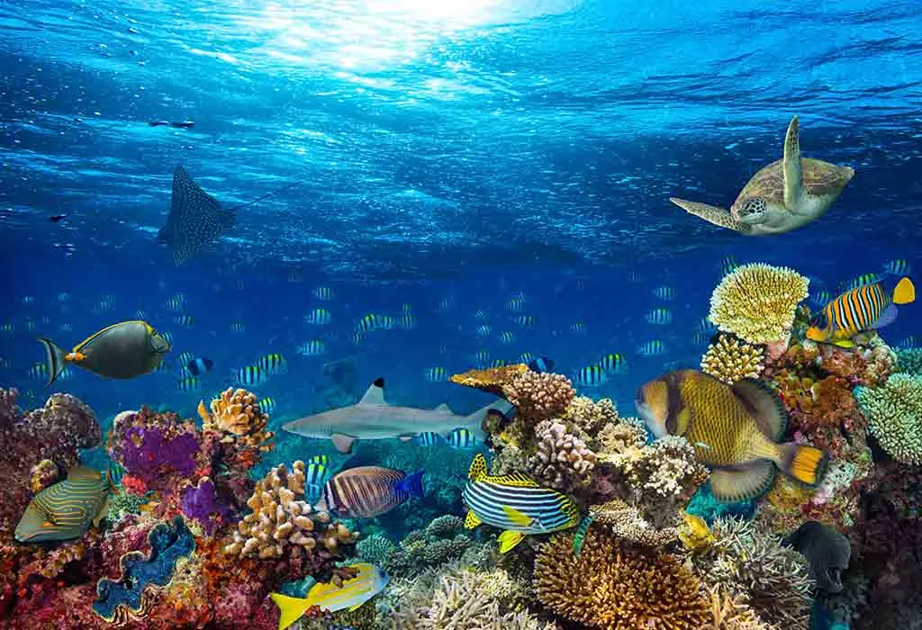 | Music Inspired by the World Around Us | - In The Sea – Respond  - “In The Sea” – Sing / “Spring” (Vivaldi)  - “Moonlight Sonata” / “In The Sea” – Sing  - “Dance of the Cygnets” / “In The Sea” – Sing  - In The Sea – Perform / Mars (Holst)  - Connect It / “In The Sea” – Sing & Perform
Computing  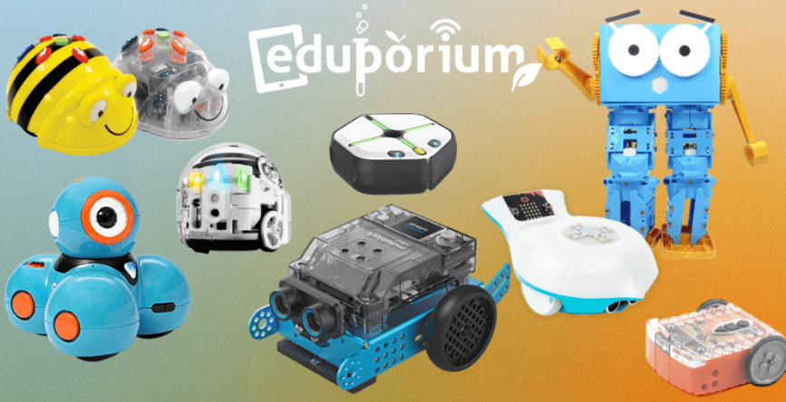 | Programming a moving robot | - To explain what a given command will do  - To act out a given word  - To combine ‘forwards’ and ‘backwards’ commands  - To combine four directions commands to make a sequence  - To plan a simple program  - To find more than one solution to a problem
PHSE  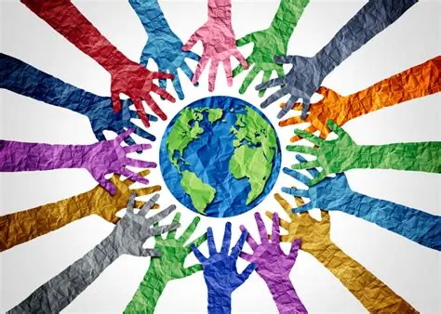 | Citizenship | - To recognise the importance of rules  - To understand that animals have different needs and how to care for them  - To recognise the needs of babies and younger children  - To begin to recognise ways which we are the same and different to other people  - To identify the groups that people belong to  - To recognise how democracy works
RE   | What do Jewish people remember on Shabbat? | - To retell events of the Jewish Creation story  - To explore artefacts  - To compare rules and beliefs  - To ask questions  - To understand the importance of rest  - To compare and express our learning
PE (indoor)  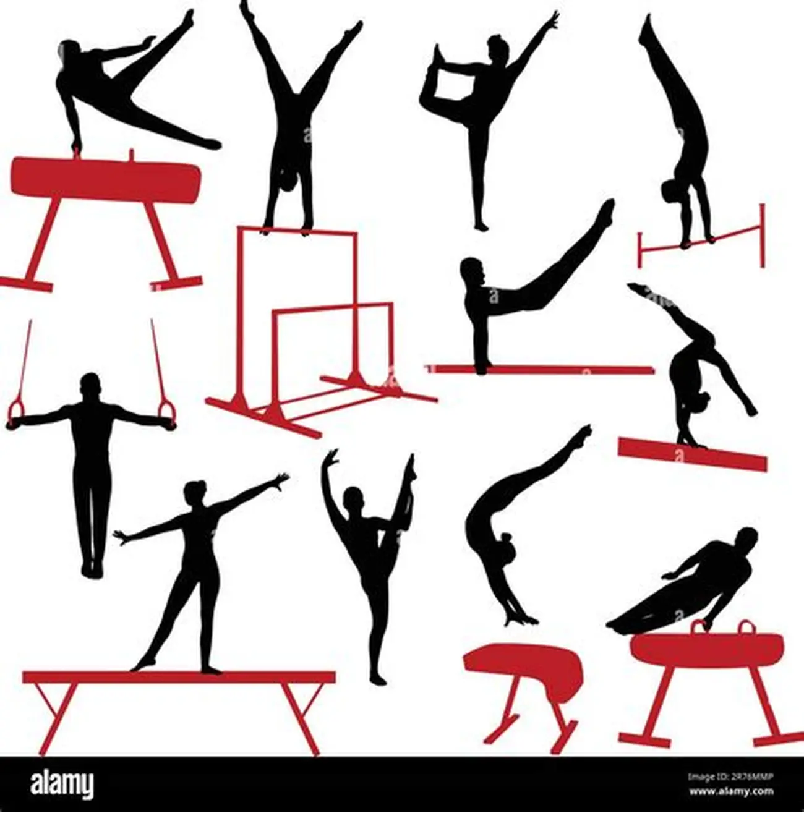 | Gymnastics | - To explore travelling movements  - To develop quality when performing and linking shapes  - To develop stability and control when performing balances  - To develop technique when performing shape jumps  - To develop the barrel, straight and forward roll  - To link gymnastic actions to create a sequence

