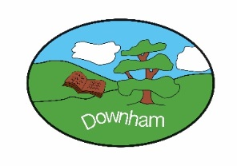
Year 5 – Owls
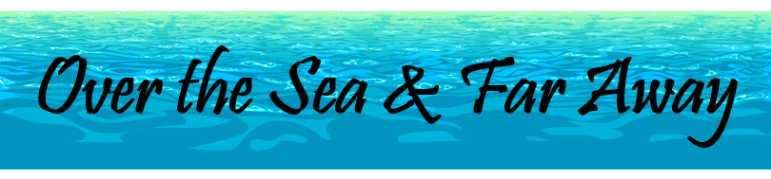

Autumn 2nd 2025
Topic Overview:
Our topic this half-term is called Over the Sea & Far Away. We will be learning about the Mayflower – it’s passengers, their motivations, the voyage, outcome and legacy. There will be a focus on our local History and the connection between Billericay and the Mayflower. In addition, we will be looking at geographical aspects as well – locations, maps and settlements.

Outcome:
For our topic ‘outcome’ we will be exploring the traditions around Thanksgiving, including some cooking with Mrs Bennett.



Hook:
We will be investigating the Mystery of Roanoke Island, and trying to discover what happened to the European colonists who vanished. Did they simply die from natural causes? Did they flee from disease or danger? Or were they captured?
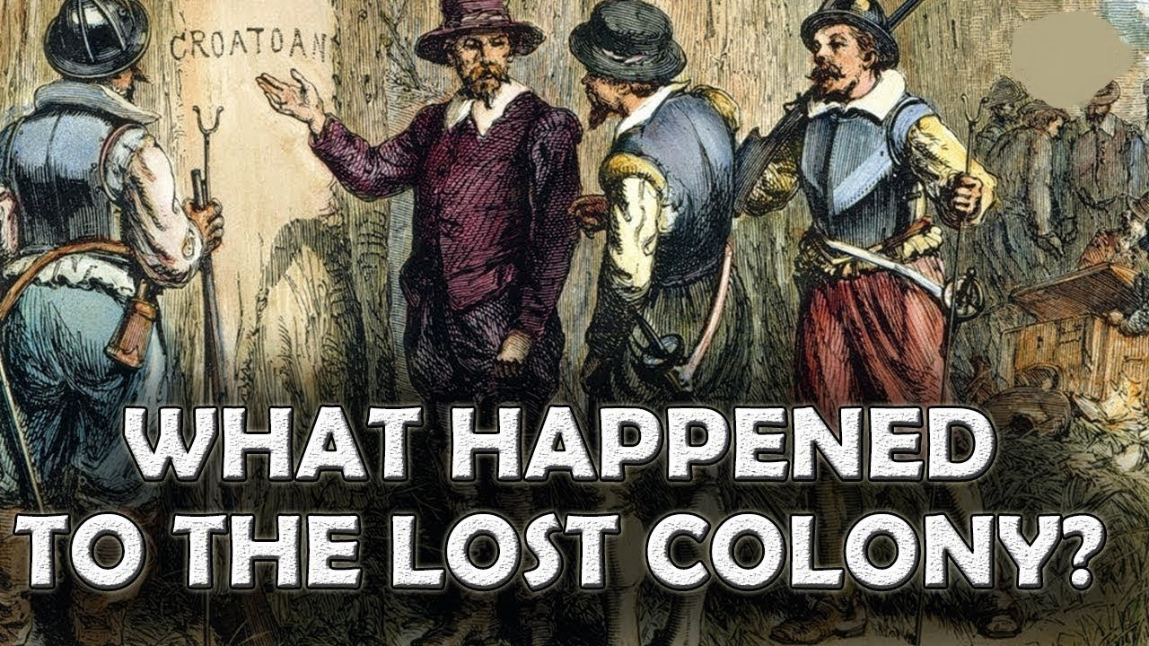
What’s being covered?
Maths | Fractions, Multiplication & Division
English | Diary Entries, Historical Narratives
 | Topic | Skills
History | Over the Sea & Far Away – The Mayflower | Chronological Understanding  - accurately use dates and terms to describe historical events  Presenting, Organising & Communicating  - Present, communicate and organise ideas about the past using detailed discussions, debates and more detailed written narratives  Historical Interpretations  - Find and analyse a wide range of evidence from the past  - Start to understand the difference between primary and secondary evidence and start to question its reliability  Historical Investigations  - Select relevant sections of information to address historically valid questions and construct detailed, informed responses  Historical Vocabulary  - Continue to build a bank of appropriate historical vocabulary and use this to talk about the past and communicate information  Knowledge & Understanding of Events & People in the Past  - Describe the key features of the past, including attitudes, beliefs and the everyday lives of men, women and children  Continuity & Change  - Understand that there are times in history when change happens suddenly and these moments can be referred to as “turning points” in history  Causes & Consequences  - Understand that the consequences of one historical event can sometimes become the causes of another
Geography | Over the Sea & Far Away – The Mayflower | Locational Knowledge:  - Identify the position and significance of latitude, longitude, Equator, Northern Hemisphere, Southern Hemisphere and use longitude and latitude to find locations on a map  Geographical Skills & Fieldwork:  - Use maps, atlases, globes and digital / computer mapping to locate countries and describe features  - Use fieldwork to observe, measure, record and present human features using a range of methods, including sketch maps, plans and graphs, and digital technologies  Human and Physical Geography  - Human geography, including: types of settlement and land use, economic activity including trade links, and the distribution of natural resources including energy, food, minerals and water
Art | Typography & Maps | - Create sketch books to record their observations and use them to review and revisit ideas  - Improve their mastery of art and design techniques, including drawing, painting and sculpture with a range of materials [for example, pencil, charcoal, paint, clay]  - Know about great artists, architects and designers in history.
DT | Cooking | - Understand about seasonality, how this may affect food availability and plan recipes according to seasonality  - Understand that food is processed into ingredients that can be eaten or used in cooking  - Demonstrate how to prepare and cook a variety of predominantly savoury dishes safely and hygienically including, where appropriate, the use of a heat source  - Demonstrate how to use a range of cooking techniques, such as griddling, grilling, frying and boiling  - Adapt and refine recipes by adding or substituting one or more ingredients to change the appearance, taste, texture and aroma  - Alter methods, cooking times and/or temperatures  - Measure accurately and calculate ratios of ingredients to scale up or down a recipe
Music | Singing –  Livin’ on a Prayer | This unit involves an integrated approach to music where games, the dimensions of music (pulse, rhythm, pitch etc), singing and playing instruments are all linked. As well as learning to sing, play, improvise and compose with this song, children will listen and appraise other classic rock songs.
Science | Materials: Mixtures and separation | - Determine the hardness of different materials and link this to their uses.  - Determine the transparency of different materials and link this to their uses.  - Determine the thermal and electrical conductivity of different materials and link this to their uses.  - Demonstrate, identify and describe reversible and irreversible changes.  - Evaluate the hardness test to determine the degree of trust in the results.  - Plan and draw a table of results.  - Write a detailed, organised and easy to follow method.  - Write a prediction using prior knowledge of the states of matter.  - Analyse observations about rusting and use them to support a conclusion.  - Measure accurately in centimetres.
Computing | Creating Media – video production | - explain what makes a video effective  - use a digital device to record video  - capture video using a range of techniques  - create a storyboard  - identify that video can be improved through reshooting and editing  - consider the impact of the choices made when making and sharing a video
PSHE | Respecting Ourselves and Others | - Recognise and maintain healthy friendship, using strategies to positively resolve disputes and conflicts.  - Recognise if friendships make us feel unsafe, worried or uncomfortable and to know how and when to seek support.  - Understand the impact of peer influence and develop strategies to manage it effectively.
French | Town and Time | - Recognise and say numbers up to 50  - Recognise and say places in town  - Recognise and tell the time
RE | How has belief in Christianity/ Islam impacted on music and art throughout history?  . | - Show awareness that talking about religion and belief can be complex.  - Explain how beliefs impact on and influence individual lives, communities and society, and how individuals, communities and society can also shape beliefs.  - Describe ways in which beliefs shape the way Christians/Muslims view the world in which they live and how they view others.
Indoor PE | Fitness | Explore and develop:  - Speed  - Strength  - Agility  - Balance  - Co-ordination  - Stamina
Outdoor PE | Tag Rugby | - Develop understanding of attacking and defending principles of invasion games  - Throwing and catching skills  - Passing and running with the ball  - Use a backwards pass effectively  - Work as a team  - Dodge to create space

