

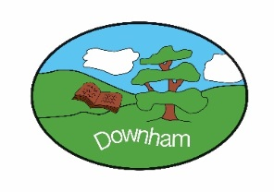
Year 1 - Robins

“Tis the season”
Autumn 2nd 2025
Our topic for this half of the autumn term will be ‘Tis the Season. The children will be exploring our incredible seasons, how they are different and how they change. We will investigate seasonal weather, with a particular focus on the changes that take place between Autumn and Winter. This term will also have a DT focus in which we will be exploring levers and sliders. We will make our own Christmas cards using these mechanisms.

Outcome:
To celebrate the differences between our seasons, exploring how the weather, plants and animals change and adapt though the year.

Hook:
To create art work using natural resources found on an Autumnal ‘hunt’.

What’s being covered?
English | In our writing lessons we will be learning how to write in different styles, including a story, a recount, and a report. When writing a story, we will practise using our imagination to create characters, settings, and exciting events. For our recount, we will learn to write about something that really happened, using time words like first, next, and finally to show the order of events. Finally, we will explore how to write a report, where we share real information and facts about a topic.
Maths | In maths, we will be practising subtraction of numbers within 10 and exploring both 2D and 3D shapes. We begin by using counters and number lines to help us solve subtraction problems, such as 8 - 3 = 5 or 7 - 2 = 5, to build confidence with smaller numbers. Alongside this, we are learning to recognise and name 2D shapes like circles, squares, triangles, and rectangles, and 3D shapes such as cubes, spheres, cones, and cylinders.
Subject | Topic | Skills
Science  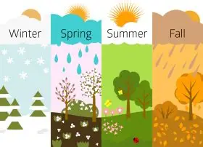  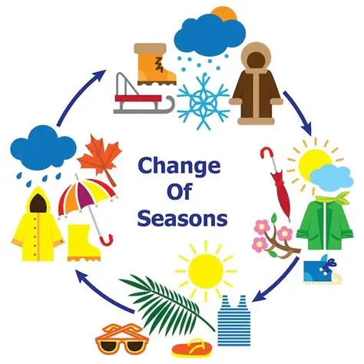 | Seasonal changes | - To identify how the weather changes across the four seasons  - To identify events and activities that take place in different seasons  - To recognise how trees change across the four seasons  - To recognise that daylight hours change across the four seasons.  - To record data in a pictogram  - To observe changes across the four seasons  - To gather and record data about how seasons change over time  - To plan and carry out a weather report
Geography  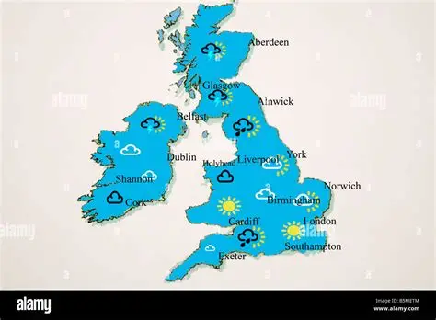 | Physical Geography | - To identify four points on a compass  - To locate hot and cold places  - To locate the four regions in the UK  - To investigate daily weather patterns in the UK  - To understand how the weather changes with each season  - To carry out a weather report
DT  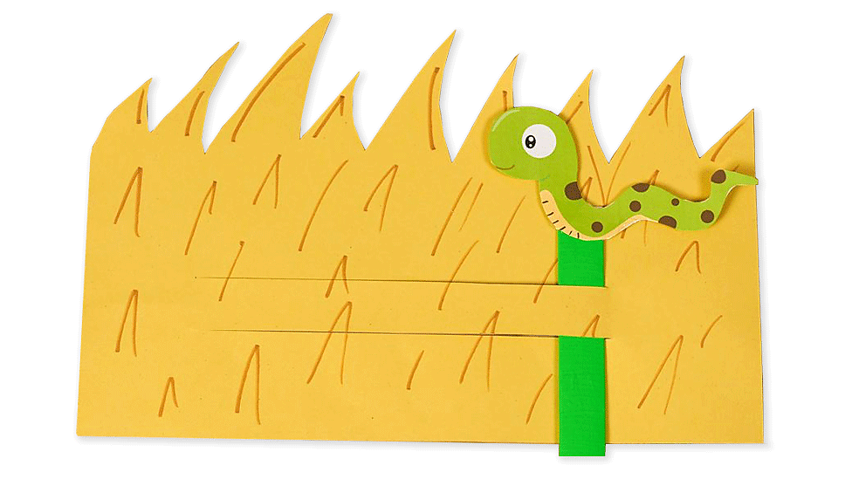 | Mechanisms: Matching slider game | - To identify slider mechanisms and describe how they move  - To make and improve slider mechanisms  - To design a sliding Santa chimney  - To make a sliding Santa chimney  - To make a sliding Santa chimney  - To test and review a sliding Santa chimney
Music  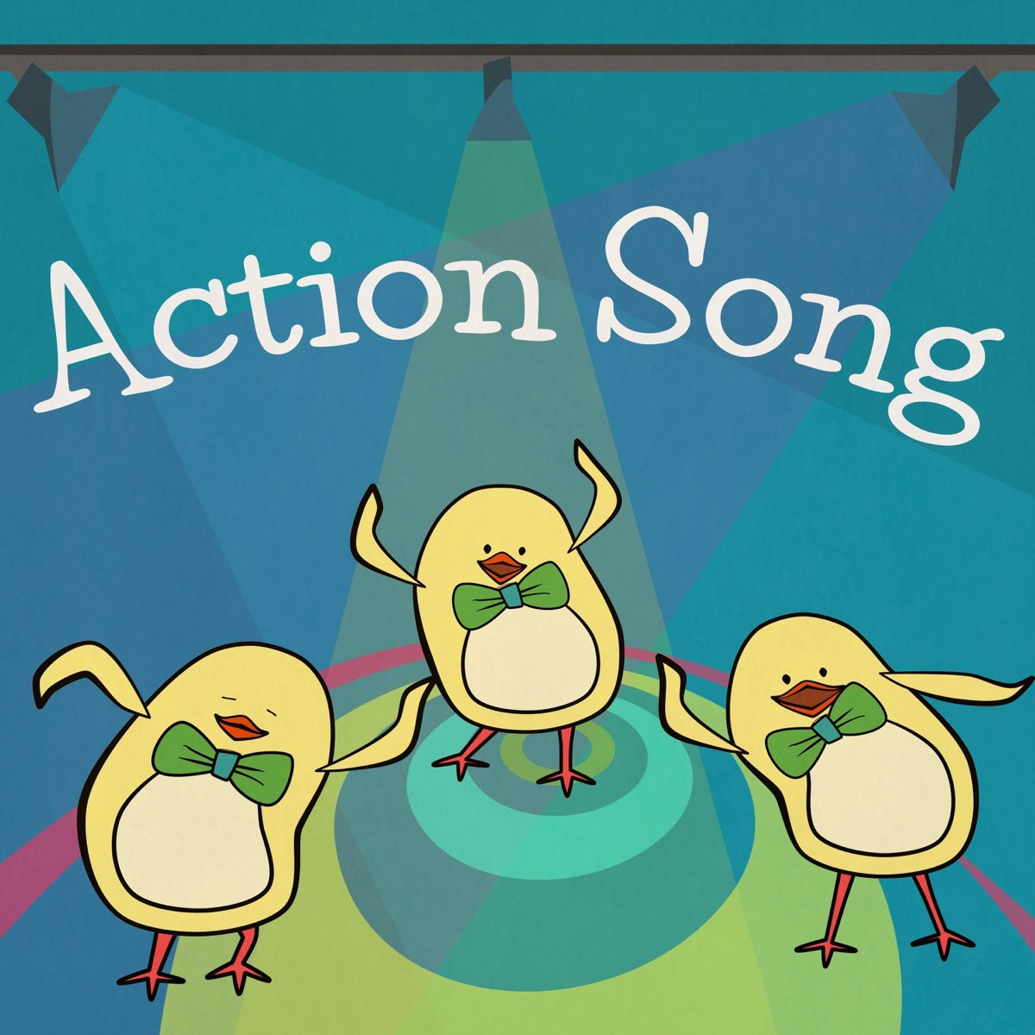 | Action songs | - Rhythm In The Way We Walk (Listen and Appraise)  - Rhythm In The Way We Walk (Musical Activities)  - Rhythm In The Way We Walk (Perform the Song)  - The Banana Rap (Musical Activities)  - The Banana Rap (Perform the Song)
Computing   | Creating media – Digital painting | - To describe what different freehand tools do  - To use the shape tool and the line tools  - To make careful choices when painting a digital picture  - To explain why I chose the tools I used  - To use a computer on my own to paint a picture  - To compare painting a picture on a computer and on paper
PHSE   | Safety and changing body | - To know how to respond to adults in a safe and familiar context  - To recognise how to respond to adults in a range of situations  - To recognise what to do if you get lost  - To know what an emergency is and how to make a phone call if needed  - To begin to understand the difference between acceptable and unacceptable physical contact  - To begin to understand what is safe to put into or onto our bodies  - To recognise that there are dangers at home and how these can be avoided  - To understand that there are people in the local community who help to keep us safe
RE   | How does a celebration bring a community together? | - To identify Christian celebrations  - To compare Muslim celebrations (Eid)  - To explore Christmas traditions  - To explore artefacts (used in Eid-ul-Fitr celebrations)  - To explore why traditions are important to Christians  - To write Christmas wishes (Christmas cards)  - To make Christmas cookies/mince pies
PE (indoor)   | Dance | - To use counts of 8 to move in time and make my dance look interesting.  - To explore pathways in my dance.  - To create my own dance using, actions, pathways and counts.  - To copy, remember and repeat actions that represent the theme.  - To explore speeds and actions

