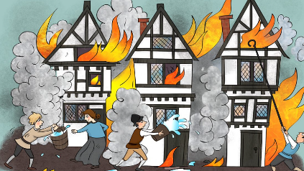
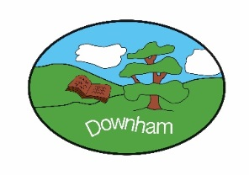
Year 2 Nightingales
Class Novels – Autumn 1
Vlad and the Great Fire of London by Kate Cunningham
The Great Fire of London: An Illustrated History of the Great Fire of 1666 by Emma Adams
Molly McDrew and the Great Fire of London by Naomi Joslyn

Fire!
Autumn 1st 2025
Topic Overview:
Our topic this term is predominantly history based. We will be learning about the key events of the Great Fire of London and understanding the ways in which we can find out about the past. The children will have the opportunity to increase their awareness of the past by learning about what London was like in the 17th century; also make comparisons with present day and consider how some problems, such as the lack of an organised fire brigade and the type of buildings, caused the fire to spread. They will begin to learn how historical sources can tell us about what happened in the past and how some sources are more useful than others.
Hook:  Play The Great Fire of London interactive game. |  |  | Outcome:  Fire Brigade Visit.
What’s being covered?

Maths | Place value, addition and subtraction and geometry.
English | Diary entries, newspaper reports and poetry.
 | Topic | Skills
History | The Great Fire of London | - Events beyond living memory that are significant nationally and globally.  - Understand the methods of historical enquiry  - The lives of significant individuals in the past who have contributed to national and international achievements.
DT | Structures  The Kings Chair | - Generate ideas based on simple design criteria and their own experiences, explaining what they could make.  - Select and use tools, equipment, skills and techniques to perform practical tasks, explaining their choices.  - Select new and materials, components, reclaimed materials and construction kits to build and create their products  - Evaluate their product by discussing how well it works in relation to the purpose, the user and whether it meets the original design criteria.
Music | Dynamics  Timbre and Tempo | - Understand that Dynamics is the word we use to describe how loud or quiet a piece of music is.  - Describe how changing dynamics can change how listener feels about a piece of music.  - Understand that Timbre describes the unique sound of a voice or instrument.  - Describe whether the sound is (thick, thin, scratchy piercing)  - Understand that Tempo describes how fast or slow music is played.  - Understand the tempo of music can change the way it makes you feel. (Fast music might make you excited. Slow music might make you feel calm, or even sleepy!)
Computing | Information technology around us | - Develop their understanding of what information technology (IT) is and will begin to identify examples.  - Discuss where they have seen IT in school and beyond, in settings such as shops, hospitals, and libraries.  - Investigate how IT improves our world, and they will learn about the importance of using IT responsibly.
PSHE | Keeping Safe  Emergency services | - Identify how to respond if there is an accident and someone is hurt.  - Identify whose job it is to keep us safe and how to get help in an emergency, including how to dial 999 and what to say.
RE | Big Question:  Why is light an important symbol? | - Retell at least one narrative where light is an important symbol.  - Recognise that the narratives used by Christians, Hindus and Jews reflect their key beliefs.  - Give an example of how Christians, Hindus and Jews use beliefs (and the symbolism of light) to guide their daily lives.
PE | Yoga  Ball Skills | - To learn about mindfulness and body awareness.  - Practice poses and techniques that will help to connect with mind and body.  - To develop existing throwing and catching skills, while introducing new skills for children to practise and develop.  - To evaluate their own performance.

