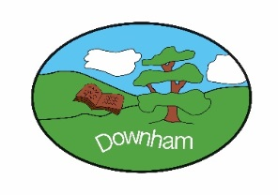
Year 5 – Owls

Tudors: Trials & Tribulations

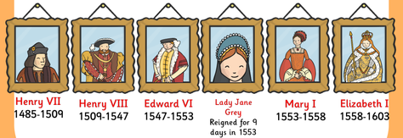

Autumn 1st 2025
Topic Overview:
This half-term Owls will be investigating the Tudors, staring with a look at the War of the Roses and how Henry Tudor became king of England. We will take a look at Henry VIII and how Hans Holbein (the great portrait artist) played an important role in creating the king we now know. Which of Henry VIII’s wives was the most significant? We’ll find out! We will also be looking at other key events during his reign (the translation of the Bible into English, the break with the Catholic Church and the dissolution of the monasteries). From there, we will go on to study the reigns of Henry VIII’s children, and Lady Jane Grey! Where does Mary Queen of Scots fit in? What was the Spanish Armada and can it really be considered a turning point in British History?

Sometimes our families may feel a little dysfunctional but, as we look at the Tudors, we will see what a truly dysfunctional family looks like!

Outcome:
Rise and Shine Assembly
Friday 24th October 2025
9.15 – 9.45am

Hook:
Who should be king? Investigating the Princes in the Tower and the various theories behind their disappearance, leading up to the Battle of Bosworth between Richard III and Henry Tudor.
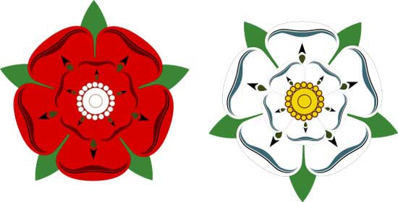
What’s being covered?
Maths | Place value including Roman numerals and numbers to 1,000,000, addition and subtraction.
English | Character descriptions, newspaper reports / journalistic writing, and poetry
 | Topic | Skills
History | The Tudors | Chronological Understanding  - accurately use dates and terms to describe historical events  Presenting, Organising & Communicating  - Present, communicate and organise ideas about the past using detailed discussions, debates and more detailed written narratives  Historical Interpretations  - Find and analyse a wide range of evidence from the past  - Start to understand the difference between primary and secondary evidence and start to question its reliability  Historical Significance  - Identify historically significant people and events from a period of history and give some detail about what they did / what happened and what impact they had  Historical Investigations  - Recognise when they are using primary and secondary sources of information to investigate the past  - Select relevant sections of information to address historically valid questions and construct detailed, informed responses  Historical Vocabulary  - Continue to build a bank of appropriate historical vocabulary and use this to talk about the past and communicate information  Knowledge & Understanding of Events & People in the Past  - Describe the key features of the past, including attitudes, beliefs and the everyday lives of men, women and children  Similarities & Differences  - Explain and give varied examples of how life was similar and different in the past  Continuity & Change  - Understand that there are times in history when change happens suddenly and these moments can be referred to as “turning points” in history  Causes & Consequences  - Understand that the consequences of one historical event can sometimes become the causes of another
Art | Typography  Study of an artist – Hans Holbein | - improve their mastery of art and design techniques, including drawing, painting and sculpture with a range of materials [for example, pencil, charcoal, paint, clay]  - know about great artists, architects and designers in history.  - Give detailed observations about notable artists’ work
Music | Living on a Prayer | - Identify the structure and instruments used in a piece of music  - Find the pulse when listening to a piece of music  - Singing in unison.  - Play instrumental parts accurately and in time as part of the performance.  - Improvise in the lessons and as part of the performance  - Compose a melody using simple rhythms and use as part of the performance
Science | Materials: Mixtures and separation | - Define the term mixture and name some common examples.  - Define the term sieving and explain how sieving separates mixtures.  - Define the term filtering and explain how filtering separates mixtures.  - Define the terms solution and dissolve and name some common examples of solutions.  - Recall some factors that affect the time taken to dissolve.  - Describe the effect of temperature on the time taken to dissolve.  - Define the term evaporating and explain how evaporating separates solutions.  - Identify when sieving, filtering and evaporating should be used.  - When working scientifically pupils who are secure will be able to:  - Research a mixture to find out what substances it is made from.  - Draw and annotate a diagram to explain how sieving separates a solid-solid mixture.  - Identify and justify which type of enquiry to use to answer my testable question.  - Identify solutions by observing and describing their appearance.  - Suggest which variables to change, measure and control when investigating how temperature affects the time taken to dissolve.  - Choose which measurements to take and how long to take them for.
Computing | Computing systems and networks - systems and searching | - Understand computer networks, including the internet; how they can provide multiple services, such as the World Wide Web, and the opportunities they offer for communication and collaboration
PSHE | Families and Relationships | - Describe what qualities a good friend should have and recognise which of these they have and which they could develop.  - Recognise that friendships have ups and downs and this is normal.  - Understand what marriage is and know that it is a choice people make.  - Understand that we all have a range of attributes that make us who we are and we should be proud of these.  - Understand that sometimes families can make children feel unhappy or unsafe.  - Understand why someone might bully others.  - Understand that attitudes and laws around gender equality have changed over time.  - Understand that stereotypes exist and these can lead to discrimination.
French | Town and Time | - Recognise and say numbers up to 50  - Recognise and say places in town  - Recognise and tell the time
RE | Is Believing in God Reasonable?  . | - Explain different philosophical and theological answers to questions about a belief in God  - Explain some of the different ways in which philosophers understand abstract concepts such as arguments for the existence of God, e.g. Pascal’s Wager and Humanism as a philosophical stance  - Explain, using a range of reasons, whether a position or argument is coherent and logical  - Link a range of different pieces of evidence together to form a coherent argument to support or oppose the existence of God
Indoor PE | Dance | - Choreograph dances by using, adapting and developing actions and steps from different dance styles  - Confidently use dynamics to express different dance styles  - Confidently use direction and patterning to express different dance styles  - Confidently use formations, canon and unison to express a dance idea  - Perform dances expressively, using a range of performance skills, showing accuracy and fluency
Outdoor PE | Hockey | - Develop control when sending and receiving under pressure  - Dribble with some control under pressure  - Explore moving to create space for themselves and others in their team  - Use a variety of techniques to lose an opponent e.g. change of direction or speed  - Develop tracking and marking with increased success  - Explore intercepting a ball from an opponent

