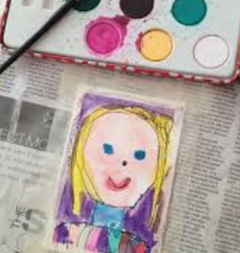
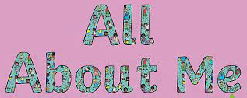
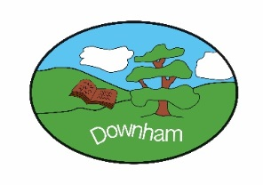
Year 1 - Robins

“All About Me”
Autumn 1st 2025

In this topic, children will celebrate how amazing they are and begin to look at their own history. They will develop an understanding of different families and friendships whilst recognising personal areas of character strengths. They will learn about the human body and how we use our senses. In Art, children will be create spirals based on the work from Molly Haslund and in music they will be focusing on keeping a pulse with different parts of the body.

Hook:
To play 'Guess who' from our baby pictures.
Outcome:
To celebrate and explain differences and similarities between ourselves and others. To say what makes us special.

What’s being covered?
English | Children will have a RWI session daily in addition to building writing and fluency. This half term, the children will be practicing descriptive writing about characters and settings using language that helps create a picture in the readers mind. We will also be looking at autobiographies, specifically looking at using lists, labels and capitations as part of our non-fiction writing.
Maths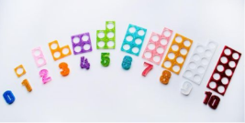 | The children will be developing their knowledge of number and place value. Children will start by learning to count using one-to-one correspondence, they will learn to recognise numbers presented in a variety of different ways e.g. numeral, word, numicon, cubes, bead strings and dominoes. Children will continue to learn correct number formation.
Subject | Topic | Skills
Science  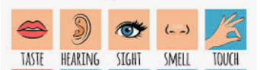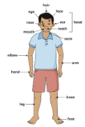 | Sensitive Bodies | - To name parts of the human body, compare and group them.  - To learn the body parts used for the 5 senses.  - To identify the body parts used for the sense of taste and touch and use them to make observations.  - To recognise how sight is used to navigate obstacles safely and use smell to identify mystery scents.  - To investigate how sound changes as you move further away.  - To recognise how the senses are used in everyday life.
History  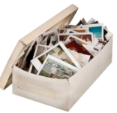 | How am I making history | - To create a personal timeline, developing an understanding of personal chronology.  - To investigate personal history by recalling on memories from their past.  - To explore how we remember events  - To learn what was childhood was like for their parents  - To compare childhood now with childhood in the past.  - To identify that some things change and some things stay the same.  - To find out what the children have learnt
Art  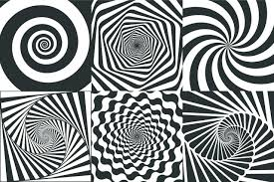 | Spirals | - To make drawings using your body  - To develop drawings  - To introduce sketchbooks and personalise  - To use observational drawing  - To use experimental mark-making  - To share, reflect and discuss
Music  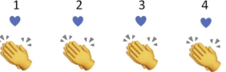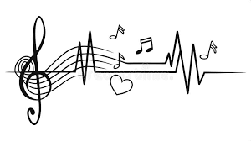 | Keeping the pulse | - To demonstrate an understanding of pulse using parts of the body.  - To keep a pulse and show a sound pattern using bodies and voices.  - To explore using a thinking voice to show the pulse.  - To play short rhythms in time with the pulse.  - To demonstrate an understanding of pulse through performance.  - To explore and change dynamics using the voice.
Computing  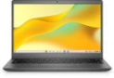 | Computer systems & mouse skills | - To log in to a computer and access a website  - To develop mouse skills  - To use mouse skills to draw and edit shapes.  - To create a self-portrait using digital techniques.  - To recognise what the internet is and how to use it safely.
PHSE  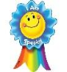 | Families & friendships | - To begin understanding what PSHE is and how we can learn effectively in these lessons.  - To understand that families look after us.  - To begin to understand the importance and characteristics of positive friendships.  - To begin to understand that friendships can have problems but we can overcome them.  - To begin to understand that being friendly to others makes them feel welcome and included.  - To begin to understand what is meant by a stereotype.  - To describe and understand my feelings.  - To develop simple strategies for managing them.  - To understand the NSPCC Pants Rule.
RE   | What do my senses tell me about the world of religion and belief? | - To give my opinion based on my senses  - To ask questions  - To identify and label  - To give reasons  - To express a welcome using senses
PE (indoor)  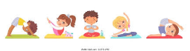 | Yoga | - To explore yoga and mindfulness  - To be able to copy and remember poses  - To develop flexibility whilst holding poses  - To develop balance whilst holding poses  - To create yoga poses using a hoop  - To create a yoga flow with a partner

