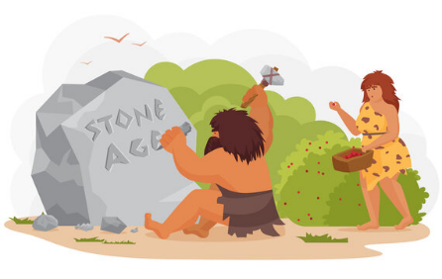
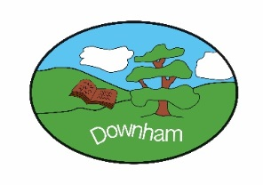
Year 3 – Woodpeckers
Class Novel
Wreck of the Zanzibar
The Stone Age
Autumn 1st 2025

Topic Overview:

In this topic we will explore the meaning of ‘prehistory’; learn why it was called the Stone Age; when it was and how long it lasted in Britain as well as the different periods during the Stone Age. We will learn about how people lived – their homes, their diet and what they did for fun.

Outcome:
Stone Age cave shoe boxes
Hook:
Pom Pom Woolly Mammoths

What’s being covered?
Maths | Place value – read, represent, partition, order numbers to 1000. Add and subtract 2 and 3 digit numbers
English | Instruction writing and playscripts
 | Topic | Skills
History | Stone Age in Britain | - To learn about the changes in Britain from the Stone Age to the Iron Age  - Develop a chronology of the Stone Age – the events of the Stone Age  - Develop appropriate use of historic terms  - To find about how people lived – their homes, what they ate and how their diet changes  - To consider life in the Stone Age and how it compares with life today.
Art | Gestural drawings with charcoal | - See how artists use charcoal in their work.  - Talk about the marks produced and how children feel about their work.  - Experiment with types of marks made with charcoal using hands.  - Work on larger sheets of paper, making loose, gestural sketches using body.  - Use light and dark tonal values to create a sense of drama  - Use body as a drawing tool to make drawings inspired by movement and see how other artists do the same.
Music | “Let Your Spirit Fly” | - Play and perform in solo and ensemble contexts, using their voices and playing musical instruments with increasing accuracy, fluency, control and expression  - Improvise and compose music for a range of purposes using the inter-related dimensions of music  - Listen with attention to detail and recall sounds with increasing aural memory  - Appreciate and understand a wide range of high-quality live and recorded music
Science | Plants | - Identify what plants need to grow healthily.  - Describe the structure and function of the parts of flowering plants.  - Investigate how plants transport water.  - Describe the life cycle of a flowering plant.  - Explain seed dispersal methods.
Computing | Computing systems and networks – Connecting computers | - To explain how digital devices function  - To identify input and output devices  - To recognise how digital devices can change the way that we work  - To explain how a computer network can be used to share information  - To explore how digital devices can be connected  - To recognise the physical components of a network
PSHE | Families & Relationships | - Understand that families are all different.  - Know that families offer each other support but sometimes they can experience problems.  - Understand that problems occur in friendships and that violence is never right.  - Understand what bullying is and what to do if it happens.  - Describe what a good listener is and know how to show that they are listening.  - Say who they trust and why.  - Understand that people can have similarities and differences and explain how differences can be a positive thing.  - Understand how toys can reinforce gender stereotypes.  - Understand that stereotypes arise from a range of factors, including some of those associated with age.
French | Introduction to French | - Learn how to greet and say goodbye  - To learn how to ask and say your name  - To learn how to say and respond to classroom instructions  - To identify France and Paris on a map and learn about the culture  - To learn the numbers 1-3
RE | How do people express commitment to a religion/ worldview in different ways? | - Identity a range of ways in which religious belief can impact daily life  - Show awareness of the similarities and differences between the commitment ceremonies or rites of passage within Christianity and between Christianity, Judaism and Sikhism  - Identity some similarities and differences in how people practise and express beliefs about commitment
PE | Ball Skills  Yoga | - To develop dribbling skills with hands and feet, develop tracking, throwing, catching and kicking skills.  - To track a ball that is not sent directly to me and apply sending and receiving skills in games.  - To explore and create a flow of poses that challenge balance, flexibility and strength.

