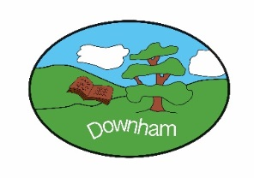
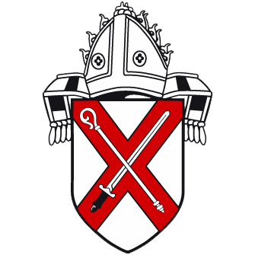


Curriculum Overview
Year 3
2025 – 2026
“Inspiring all to soar to new heights.”
Challenge Courage Collaboration Critical Thinking Creativity



Term | Autumn 1 | Autumn 2 |  |  | Spring 1 | Spring 2 | Summer 1 |  | Summer 2
Theme | The Stone Age | Coast to Coast |  |  | Forged in Fire | B&B by the Sea | Veni. Vedi. Vici |  | Natural Disasters
Curriculum Enrichment | Pom Pom woolly mammoths  Cave shoe boxes using natural materials. | Beach-inspired arts and crafts and collage boats paintings. |  |  | Class Trip to Chelmsford Museum to be archaeologists for the day.  Board game afternoon. | Spanish-themed day – food tasting, arts and crafts, music and dance | Roman inspired arts and crafts  Trip to Colchester Castle |  | Making a volcano.  Class quest to ‘escape Mount Vesuvius
Speaking & Listening | Targeted questioning / listening / referring back to the text
PE  (Get Set 4 PE) | Yoga Y3&4  Ball Skills Y3&4 | Tag Rugby  Dance |  |  | Netball  Gymnastics | Football  Fitness | Cricket  Athletics |  | Tennis  Rounders
PSHE  (Kapow) | Setting ground rules  Families & Relationships | Health & Wellbeing |  |  | Safety & the Changing Body | Citizenship | Economic Wellbeing |  | Transition
English
Driver Texts | Wreck of the Zanzibar | Stig of the Dump |  |  | Stig of the Dump | The Iron Man | Sky Hawk |  | Escape from Pompeii
Poetry & Drama | How to write a Haiku | How to write a list poem |  |  | How to write a diamante poem | How to use similes | How to learn from a poet |  | How to create mood in a poem
Fiction | How to describe settings | How to write a guided voyage and return story |  |  | How to write a tricking the monster story | How to write a warning story | How to write a triumphing story |  | How to perform a scene
Non-Fiction | How in inform the reader | How to write an account for events |  |  | How to write instructions for games | How to write a persuasive flyer | How to write and deliver a presentation |  | How to explain
Mathematics   | Place Value  Addition and subtraction | Multiplication and division A |  |  | Multiplication and division B  Lenth and perimeter | Fractions A  Mass and capacity | Fractions B  Money |  | Time  Shape  Statistics
 | Working scientifically: Pupils will experience different types of scientific enquiries, including practical activities, and begin to recognise ways in which they might answer scientific questions throughout each topic.
Science  (Kapow) | Plants: Plant reproduction | Energy: Light & Shadows |  |  | Forces & Space: Forces & Magnets | Science Week - Scientists & Inventors | Animals: Movement & Nutrition |  | Materials: Rocks & Soils
Computing  (Teach Computing) | Computing systems and networks – Connecting computers | Creating media - Stop-frame animation |  |  | Programming A - Sequencing sounds | Data and information – Branching databases | Creating media – Desktop publishing |  | Programming B - Events and actions in programs
National Online Safety | SMART rules, logging on/off,  Online relationships  Online reputation  Online bullying |  |  |  | Self-image & identity  Health, wellbeing & lifestyle |  | Copyright & ownership  Privacy & security  Managing online information
Geography |  |  |  | Geographical skills and field work  Locational knowledge |  | Locational knowledge  Human Geography |  |  | Geographical skills and field work  Place knowledge  Human Geography
History | The Stone Age in Britain |  |  |  | Bronze Age – Iron Age |  | Romans in Britain
RE  Essex Agreed Syllabus | Theology: Asking questions theologians ask  Philosophy: Asking questions philosophers ask  Human/Social Sciences: Asking questions human and social scientists ask
RE  Essex Agreed Syllabus | How do people express commitment to a religion/ worldview in different ways?  (Hindu or Jewish/Sikh) | Christian What is the Trinity? |  |  | What is philosophy? How do people make moral decisions? Christian/Humanist | Understanding Christianity: Salvation | What do Muslims believe about God? |  | What difference does being a Muslim make to daily life?
Music  (Charanga) | Let your spirit fly | Glockenspiel stage 1 |  |  | Three little birds | The dragon song | Bringing us together |  | Reflect, rewind and replay
DT  (Kapow) | To master practical skills
DT  (Kapow) |  |  | Structure – Make a castle  (Sandcastle) |  |  | Textiles – cross stitch & applique cushions  Easter themed |  | Food technology – Seasonal Vegetable Tarts  (Mediterranean Tart)
Art  (Access Art) | Gestural Drawing with Charcoal – Stone Age pictures |  |  |  | Working with Shape and Colour (collage)  Hillfort scene/landscape |  | Telling Stories – sculpture of Caesar /Boudicca/ Claudius

